Emergency Solutions Grant, (ESG) Application Submission Instructions through the ADFA Programs Portal
The instructions provided in this guide will provide detailed application submission instructions through the ADFA Programs Portal. The ESG application and all required attachments must be fully completed and executed prior to submission through the Programs Portal.
ESG Application Submission
- Applicant/User must have an ADFA Provider Number to access the ADFA Programs Portal. (Applicant and User are interchangeable in this manual)
- Complete ESG PDF Application and all required attachments.
- Log into ADFA Programs Portal and create password, (if you are a first-time user). If an applicant already has a Provider Number use the same Provider Number to submit the ESG application.
- Follow the application submission instructions provided in this guide to submit the ESG application.
- If a user cannot complete the application submission process or is timed out and must log back into the portal there are certain steps to get back to the ESG application that was started. Do not click on New Application again. Click on manage application and click on the ESG application that was started. Complete instructions have been provided at the end of this document.
_____________________________________________________________________________________________________
The instructions below provide detailed steps that will assist an applicant in submitting a completed ESG application into the ADFA Programs Portal. There are 6 detailed instruction steps.

ESG Application Submission Detailed Steps

Step # 1 Web Link to the ADFA Programs Portal & Accessing the Portal
If you are a first time User/Applicant follow the instructions below to access the portal. An applicant must have a Housing Provider Number to access the Portal. If you do not have a Provider Number click the link below to request a Provider Number.
Request a Provider Number Link: ESG Program Provider Setup Form
To access the Portal, highlight and click on the ADFA Programs Portal Link that is below.
ADFA Programs Portal (mitas.com)
The screen below will be the first screen that appears. Click on the Requirements tab at the bottom of the screen before you enter your agency provider number and Applicant name.
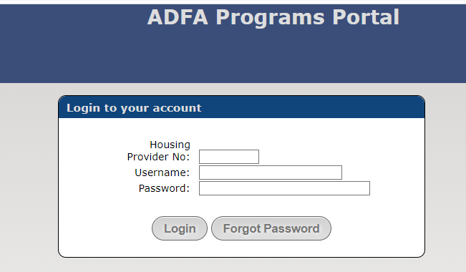

The System requirements screen will provide acceptable web Browsers that can be used to access the ADFA Programs Portal. The Browsers listed typically work well with the Portal.

Choose one of the Browser options listed in the instructions panel and ensure it has been updated to the newest version. If the Browser has not been updated or if another Browser type is being used it could cause problems for Portal Applicants. If necessary, log out, change, or update the Browser and log back into the portal.

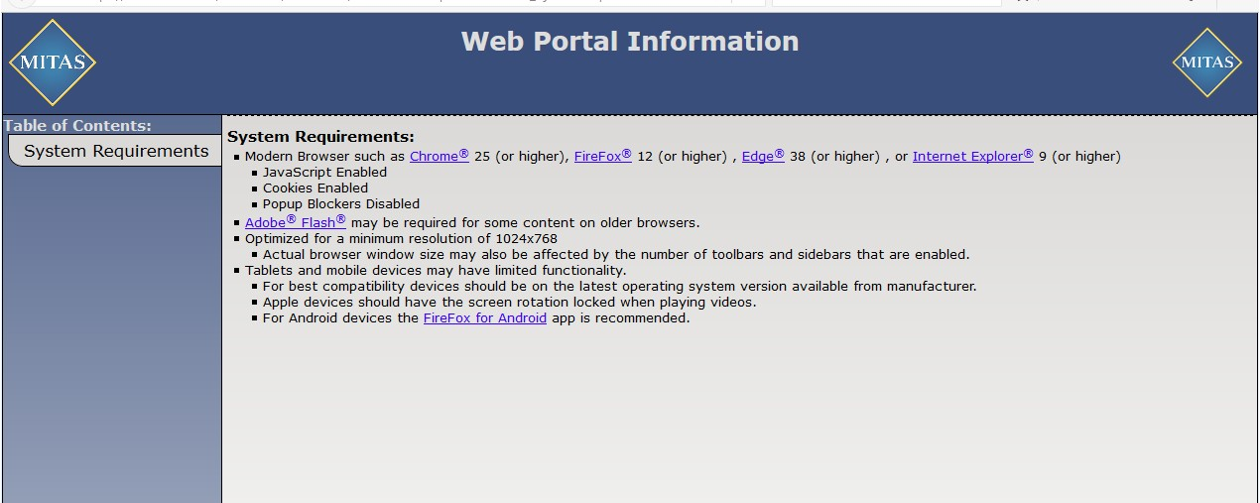
Verify that you have an acceptable updated browser and enter the Housing Provider Number and Username that was provided by your Portal Administrator or if you are the Administrator the Housing Provider Number and Username provided by ADFA.
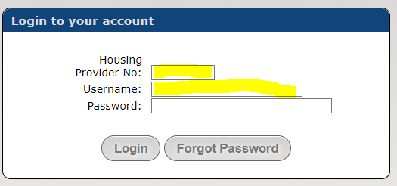
Click on “Forgot Password”
A notice that a new password has been sent to your email will appear. Check your email for the temporary password. Be sure to check your SPAM folder if necessary. If you copy and paste the temporary password it has to be the exact letters and numbers (do not include spaces before or after the password). If the copy and paste does not work, you will need to type in the password. Click on the login tab and it will prompt you to create a new and permanent password. When you have successfully changed your password and entered your credentials, the Portal HOME Screen should appear.
Note: When creating your New Password the portal will ask the user to provide the Current/Temporary Password and then enter a new password and then confirm the New Password.
It is suggested if the system is giving you a system error that you delete the Current/Temporary Password slot and re-enter the temporary password again, ensure it is correct when putting it into this slot.
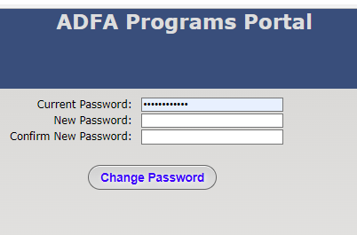
Only use the “ForgotPassword” when you actually forgot your password after you have created your new password for the first time.
If you did not receive a temporary password, contact your Portal Administrator at your agency and ADFA. Typically, if the temporary password does not come back an incorrect email has been entered in the user setup. Your agency Administrator can verify this before contacting ADFA.
Security Tip: Never share your log in information with another employee. That employee can get their own setup. User transactions are tracked by the username.

ADFA Contact Information for questions or assistance.
Susan Gardner 501-682-5931 susan.gardner@arkansas.gov or
Alisa Green 501-682-5929 alisa.green@arkansas.gov
Nicholas Sherwood 501-682-1228 nicholas.sherwood@arkansas.gov

ADFA Programs Portal Help Icon. 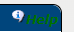
The help icon will be located thru-out the portal screens. If applicable, click on the help icon if you have questions. Icons will have help information for the current location.
Note: Some icons will not have help information in them. This is a work in progress by our software provider.

Step # 2 Home Screen and New Application Submission
The HOME screen page will appear after logging into the portal. The HOME Screen displays contact information about your agency and displays all applications and/or projects that have been submitted by your agency in the Application Status section. If your agency is a new applicant there will be less information on this page. Once you have submitted your first application it will appear like the example below.
Example of Home Page (Note: The welcome screen announcement below will change as needed)
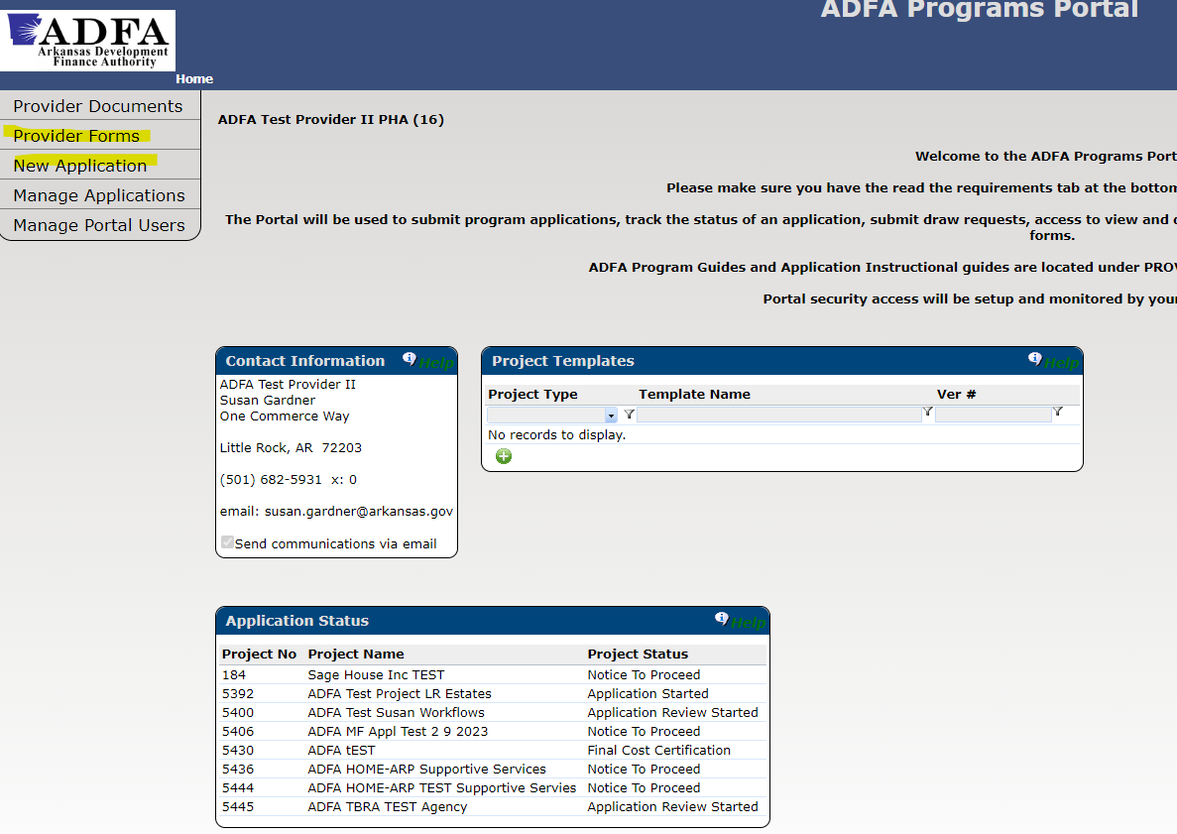

Home Page Navigation Tabs
Provider Forms | Contains Program Guides, Portal Guides and Required ADFA Form Guides
New Application | Click this tab to start a new application.  Do not click this tab if you are trying to get back into an application that has been started.
Manage Application | Allows a User to get into any application/project that has been started and/or submitted applications.
Manage Portal Users | Only the “Agency Administrator” should have access to this tab
New Application Submission Instructions
Click on New Application
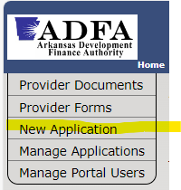

Click on the Project Type dropdown.
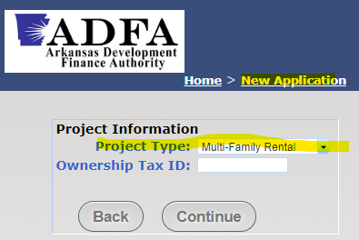

Select the ESG Project Type.

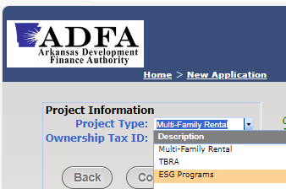

Type in 9-digit tax Id
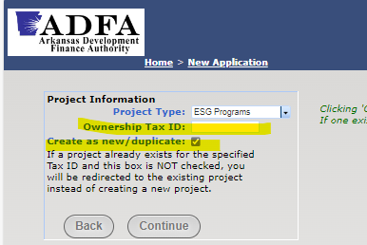
Click the box below for the ESG Program
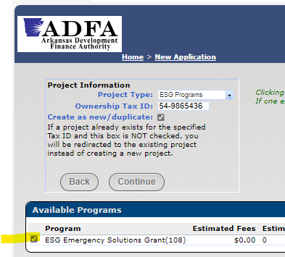

Click on Continue
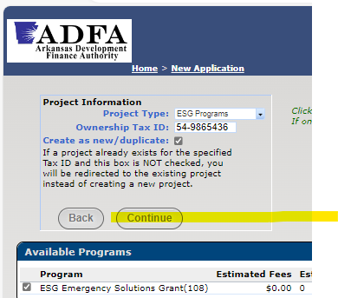
Once you click on continue it takes you to the Applications Instructions Screen.

Step # 3 Review Application Instructions Page
The application instructions screen will appear with a project number. The project number will be your application identifier. The project number should be referenced in future correspondence.
Review the Instructions provided in this section. Instructions in this section are subject to change. Click on Continue after you have read the instructions.
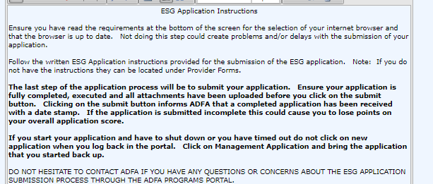

Step # 4 Complete Project Details Screen

Complete both sections below:
Mailing Address & Program Summary
Owner Address & Owner Address Roles and Experience

ESG projects will typically have the same Mailing and Owner Address. The information must be completed for both sections. Sections with an * must be completed ADFA recommends all sections are completed.

See examples of completed sections below:

Example Mailing Address & Project Summary
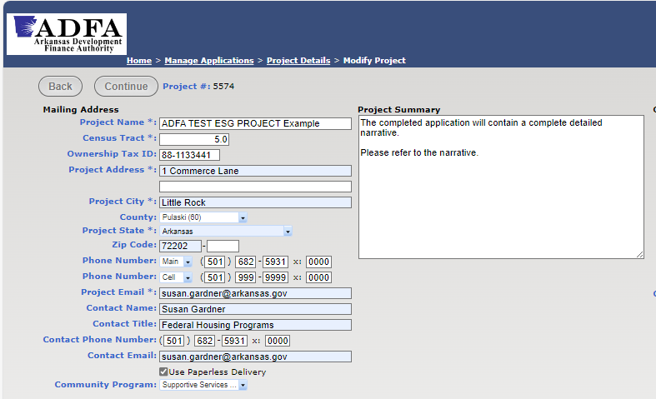

Note: Always click Use Paperless Delivery this allows ADFA to generate emails thru the software

Community Program – click the drop-down menu and select the program for the type of ESG program you are providing. If there are no programs to select leave this section blank and continue to complete the application submission.

Example of Owner Address & Owner Address Roles and Experience
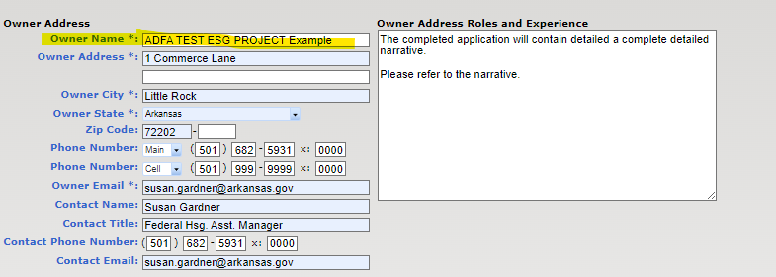

Note: It is important to enter this data for the entire page and click the continue tab before the system times-out or if the user logs out.

If the User completes this section and does not hit continue before it times-out or user logs out of the portal the data will be lost and the User will have to re-enter the data again. If this happens log back into the Portal and access the application through the Manage Application tab. Detailed instructions have been provided at the end of this document.
When both sections are fully completed click Continue.
This will take you to the following screen.
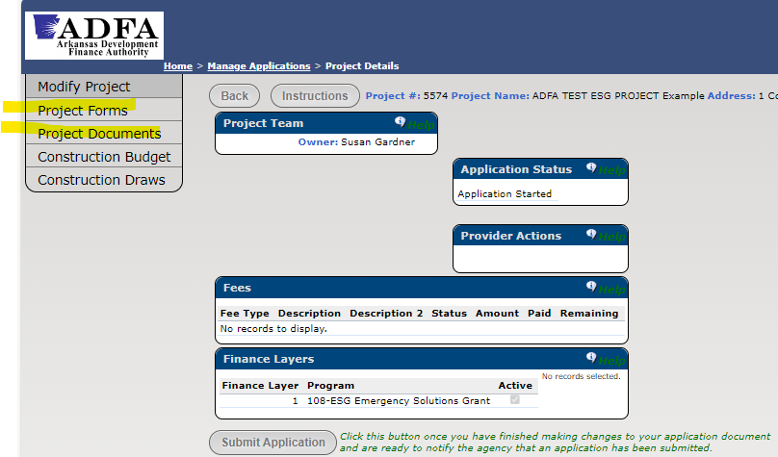
Project Forms
Project Forms contain the application and application forms. The same forms on ADFA’s website. This is a 2nd location to access the application forms. It is not necessary to click into Project Forms if you already have them.

Step # 4 Project Documents
Once you have completed and executed the ESG application and the required forms documents from the application checklist the next step will be to upload each document into the portal slot provided in the Project Documents section.
Click on Project Documents
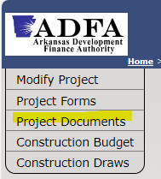
Upload Application and required forms and documents.
It is preferred that one PDF document is uploaded into the slot if there are multiple documents for the slot upload. The portal will take more than one document if a document was uploaded in error or if the upload was incomplete.
The word “latest” will appear after the first uploaded document under the Download Header. The applicant will be able to view all documents that were uploaded by clicking on latest. This is helpful to verify you have all the correct forms and documents uploaded into the correct slot.
Below is an example of what the Document screen looks like. In this example it displays the word “latest” as explained above.
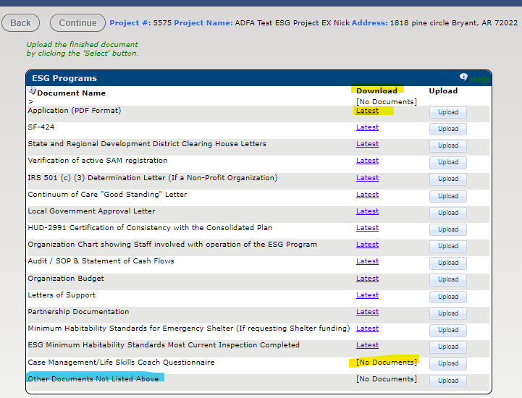
“Other Documents Not Listed Above” This slot is provided for the applicant to submit additional documentation that does not contain a specific slot for a document upload.
Example: Recent award received by the applicant, news articles, etc.

Click continue once you after uploaded all application documents and/or go back to Home page and click on the tab construction budget to get to the next step.

Step # 5 Construction Budget Uses
The Construction Budget Uses screen must be completed by the applicant.
Note: The naming of this section is Construction Budget. Do not let this Construction Budget name mislead you, (applicant preparer). ADFA realizes this is not a construction budget.
The Construction Budget Uses screen will populate the amount for each activity component that the applicant is applying for. These figures should match the total figures in the application.
Click on Construction Budget
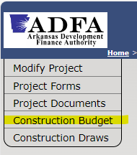
Click on the Download Import Template
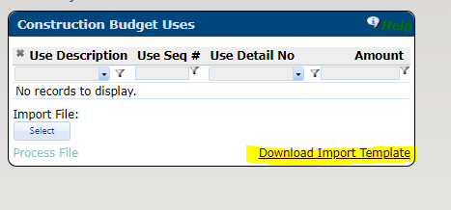

The template below will appear in a download.
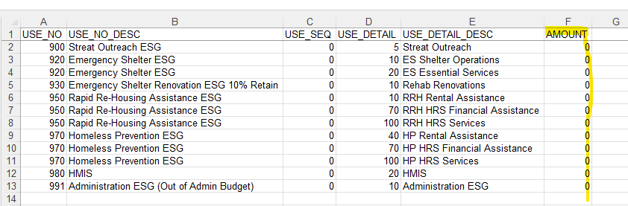
Complete the template amount Section F in the above example with the same budget figures from the application. Only enter the budget figures do not change any other fields in the template.
Verify the template matches the application for the amounts requested for each activity component. Copy the template to your computer.
Click on Select to upload the budget figures.
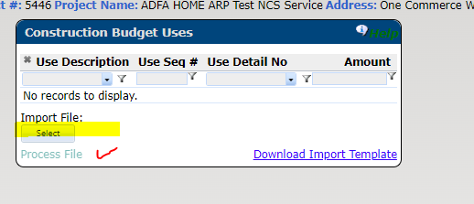
Click on Process File
The budget figures should appear in this section. Figures can be reviewed again in this section.

Example of ESG Budget figures.
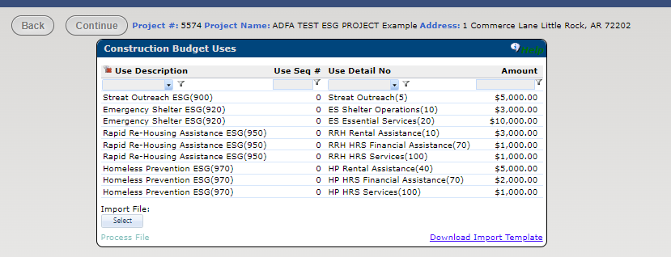

Note: If you notice an error in the budget figures after uploading the budget it can be corrected
by correcting the data on the template and uploading the template back into the portal.

Click Continue to get back to the Home Page or click on Back

Step # 6 Submit Application to ADFA from Project Details Screen
Before clicking the Submit Application
Ensure all steps have been completed in the ESG Application submission guide. All required portal screens must be completed.
The application must be completed and executed. The completed application and all required documents and forms have been uploaded.
Once the application has been submitted it notifies ADFA staff that a completed application has been submitted to ADFA. The software logs the submission date, and the application review process will start.
Click Submit Application
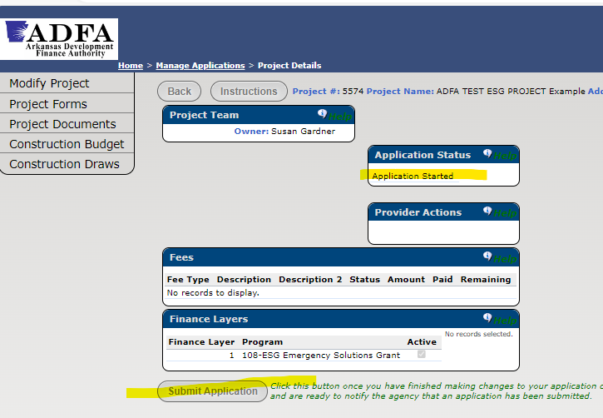
The Submit Application tab will disappear from the screen after you have submitted the application. Do not make changes to the application unless you have been directed by ADFA to do so. All transactions are date stamped and can be verified.
When you log out and back into the portal the application status will change to Application Received. Users can track the Status of their application from this location.
Example below verifies the application has been received. The Application status changed from Application Started to Application Received.
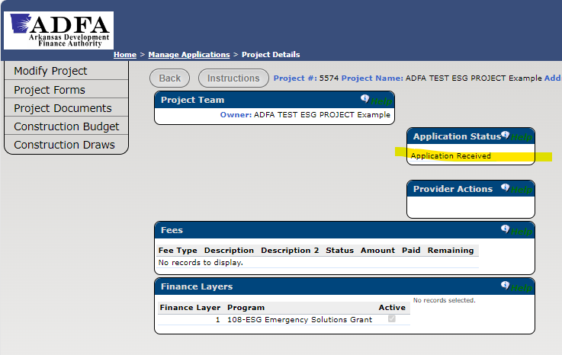
Once ADFA starts the review of the application the status will change to Application Review Started. The next status will be “Application Denied” or “Application Approved”.
This completes the submission of the ESG Application.
If the application is approved ADFA will require future correspondence to be submitted thru the ADFA Programs Portal. ADFA will provide further guidance at that time. There is a Programs Portal User Manual for Basic Navigation and Accessing Forms and Documents available in Provider Forms. This guidance may be outdated as updates to the software have been completed.
The portal will date stamp all correspondence sent and received, this process is a secure way to transmit forms and documents. Portal Users can monitor project statuses and refer to previous correspondence and completed program legal documents.
Please do not hesitate to contact ADFA if you are having any concerns about submitting your application.

ADFA Programs Portal Contact Information for portal questions or assistance:
Susan Gardner Phone: 501-682-5931 Email: susan.gardner@arkansas.gov
Alisa Green Phone: 501-682-5929 Email: alisa.green@arkansas.gov

Reminder
Instructions for how a user will get back to an application that was started but not submitted.
If a user must log out of the Portal or if you were timed out of the portal before completing the ESG application log back into the portal and follow the following steps to get back to the application that was started.
DO NOT CLICK ON NEW APPLICATION. This will start another new ESG application. If you do contact ADFA so we can delete the 2nd ESG application that was started.
Example For How to Get Back to An Application That Has Been Started but Not Submitted To ADFA.
- Log Into the Portal
- Click on Manage Applications
- Review the Application Status Box Look for the Application that was Started
- Click on the Application that was Started

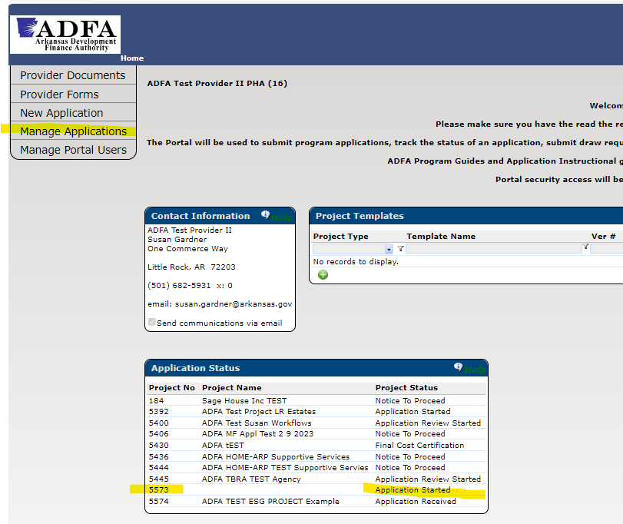

Depending on where the user left off the user may have to click on Modify Project or Project Details.
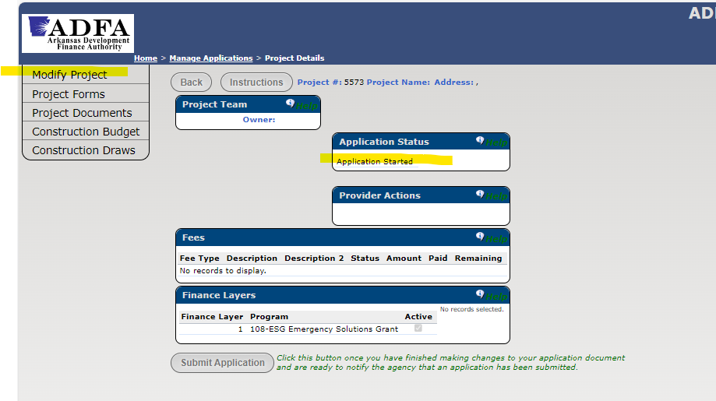
Modify Project will take the user to the following screen if not completed by the user.

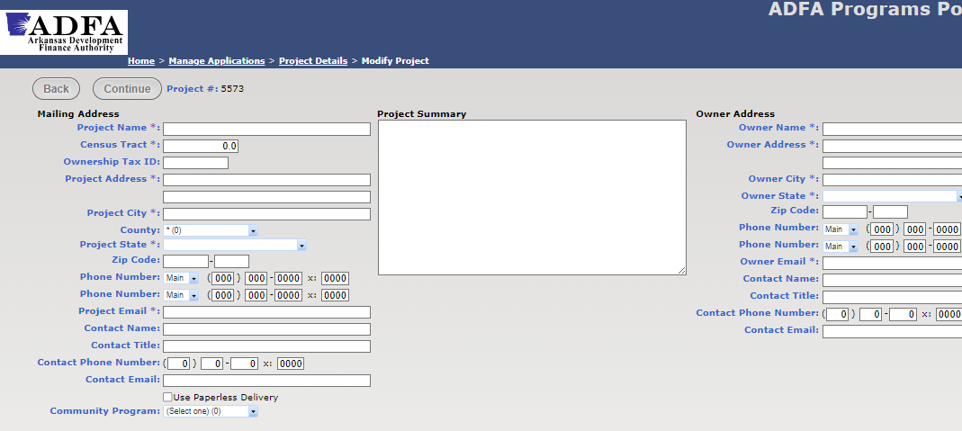
If the above screen has been completed the user can get to other screens by clicking on the screen name for Project Documents or Construction Budget.

