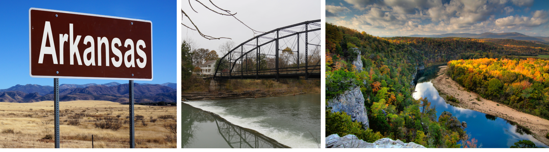
2025 CDBG-DR Action Plan
APA 1
The State of Arkansas

The State of Arkansas
2024 Disaster Events

Contents
Contents i
Action Plan Amendments 1
The following amendments have been incorporated into this Consolidated Action Plan: 1
1. Executive Summary 3
1.1 Overview 3
1.2 Disaster Specific Overview 3
Event 3
Declaration # 3
2023 Severe Storms and Tornadoes 3
DR-4698 3
2024 Severe Storms, Straight-line Winds, Tornadoes, and Flooding 3
DR-4788 3
Most Impacted and Distressed (MID) Areas 7
2. Unmet Needs and Mitigation Needs Summary 11
2.1 Unmet Needs and Proposed Allocations 11
3. Unmet Needs Assessment 13
3.1 Housing 14
Rental and Owner-Occupied Single Family and Multifamily Housing 16
Total Home Loans Approved by SBA 27
Public Housing (Including HUD-assisted Housing) & Other Housing 27
Emergency Shelters, Interim, and Permanent Housing 28
3.2 Infrastructure 29
3.3 Economic Revitalization 32
3.4 Public Services 32
3.5 Conclusion 32
4. Mitigation Needs Assessment 35
4.1 Overview 35
4.2 Increasing Hazards 37
4.3 Greatest Risk Hazards 37
4.4 Hazard Probabilities 37
4.5 Hazard Profiles 38
Severe Storm 38
Drought 44
Winter Storm/Extreme Cold 45
Flooding 47
Tornado 48
4.6 Indispensable Services 50
Vulnerability of Critical Facilities by Hazard 51
4.7 Conclusion 55
5. Connection of proposed programs and projects to unmet needs and mitigation needs. 57
5.1 CDBG-DR Program Allocation and Funding Thresholds 57
5.2 Hazard Mitigation Measures 59
5.3 Minimizing Displacement 60
6. Allocation, Award Caps, and Program Description 62
6.1 General Exception Criteria 62
6.2 Grantee Administration Activity Overview 62
6.3 Planning Overview 62
Eligible Activities: 62
National Objective: 62
Lead Agency and Distribution Model: 62
Lead Agency for Environmental Reviews: 63
Program Description: 63
Eligible Geographic Areas: 63
Maximum Amount of Assistance: 63
Mitigation Measure 63
Funding Criteria 63
Reducing Impediments for Assistance 64
6.4 Housing Overview 65
6.5 Down Payment Assistance 65
Eligible Activities: 65
National Objective: 66
Lead Agency and Distribution Model: 66
Lead Agency for Environmental Reviews: 66
Program Description: 66
Maximum Amount of Assistance: 67
Maximum Income of Beneficiary: 67
Mitigation Measures: 67
Funding Criteria: 68
Reducing Impediments for Assistance: 68
6.6 Multi-Family New Construction 72
Eligible Activities: 72
National Objective: 72
Lead Agency and Distribution Model 72
Lead Agency for Environmental Reviews 72
Program Description 72
Eligible Geographic Areas 73
Maximum Amount of Assistance 73
Maximum Income of Beneficiary 73
Mitigation Measure 73
Funding Criteria 74
Reducing Impediments for Assistance 75
6.7 Infrastructure Overview 75
6.8 FEMA Non-Federal Match 75
Eligible Activities: 76
National Objective: 76
Lead Agency and Distribution Model 76
Lead Agency for Environmental Reviews 76
Program Description 76
Eligible Geographic Areas 77
Maximum Amount of Assistance 77
Mitigation Measure 77
Funding Criteria 78
Reducing Impediments for Assistance 78
7. General Information 82
7.1 Citizen Participation 82
7.2 Consultation in the Developing of the Action Plan 82
7.3 Public Comments 84
7.4 Public Hearings 84
Access to Public Hearings 84
7.5 Consideration of Public Comments 85
7.6 Citizen Complaints 88
7.7 Modifications to the Action Plan 89
Substantial Amendment 89
Non substantial Amendment 89
7.8 Performance Reports 89
8. Appendices 91
8.1 Certifications 91
8.2 Survey Results 93

Action Plan Amendments
Public Action Plan
Public Comment Period: September 10, 2025 to October 10, 2025
Submitted to HUD: October 21, 2025, revised October 30, 2025
Approved by HUD: October 31, 2025

The following amendments have been incorporated into this Action Plan:

Action Plan Amendment 1 (Substantial)
Submitted to HUD:
Approved by HUD:

1
Executive Summary

Executive Summary

Overview
The U.S. Department of Housing and Urban Development (HUD) announced that the state of Arkansas will receive $59,048,000 in funding to support long-term recovery efforts following the 2023 severe storms and tornadoes (DR-4698) and 2024 severe storms, straight-line winds, tornadoes, and flooding (DR-4788) through the Arkansas Development Finance Authority (ADFA). Community Development Block Grant-Disaster Recovery (CDBG-DR) funding is designed to address needs that remain after all other assistance has been exhausted. This plan details how funds will be used to address remaining unmet needs in Arkansas with a focus on the HUD-designated most impacted and distressed (MID) counties of Benton, Cross, and Pulaski.
To meet disaster recovery needs, the appropriations act(s) making CDBG-DR funds available have imposed additional requirements and authorized HUD to modify the rules that apply to the annual CDBG program to enhance flexibility and facilitate a quicker recovery. HUD has allocated $59,048,000 in CDBG-DR funds to Arkansas in response to the 2023 severe storms and tornadoes (DR-4698) and 2024 severe storms, straight-line winds, tornadoes, and flooding (DR-4788) through the Allocation Announcement Notice (90 FR 4759) published on January 16, 2025 and following the guidance established in the Universal Notice (90 FR 1754) updated March 19, 2025 via memorandum. This allocation was authorized through the Disaster Relief Supplemental Appropriations Act, 2025.

Disaster Specific Overview
Table 1: Event Names and Declaration Numbers
Event | Declaration #
2023 Severe Storms and Tornadoes | DR-4698
2024 Severe Storms, Straight-line Winds, Tornadoes, and Flooding | DR-4788

March 2023 Event: On March 31, 2023, a severe tornado (rated EF3/165 MPH peak wind) tracked just over 34 miles in Pulaski County, from West Little Rock through North Little Rock, Sherwood and Jacksonville, before finally weakening on the southeast side of Cabot (Lonoke County). This single event was the most severe tornado event in Little Rock (within Pulaski County) since January 21, 1999, and was a part of a storm system that resulted in at least 177 tornadoes across multiple states, along with damaging wind and large hail. The majority of the reported tornadoes (147) occurred in northern and eastern Arkansas, with a dozen of these rated EF3 or higher. The tornado caused extensive damage across urban and suburban areas, severely impacting residential neighborhoods, schools, and commercial districts. In total, approximately 2,700 structures were damaged or destroyed, and over 60,000 power outages were reported—50,000 of which occurred in Pulaski County alone. More than fifty people were injured and one fatality was reported.
A Presidential declaration of disaster was issued on April 2, 2023, designating the event as DR-4698. This declaration allowed residents of three counties (Cross, Lonoke, Pulaski) to apply for FEMA Individual Assistance (IA). In total, 3,597 individuals were approved for a total of $9,847,643 in assistance. The table below from FEMA breaks down the approved IA funding as of March 29, 2025:
Table 2: DR-4698 Individual Assistance
Individual Assistance | Approved Amount
Total Housing Assistance (HA) | $5,494,174
Total Other Needs Assistance (ONA) | $4,353,468
Total Individual & Household Program | $9,847,643
Individual Assistance Applications Approved | 3,597

In addition to FEMA IA, the declaration extended Public Assistance (PA) to state, local, and tribal governments (along with select non-profits) in the same three counties eligible for IA (Cross, Lonoke, Pulaski). The map below displays counties designated for both FEMA IA and PA:
Figure 1: FEMA Designated Areas: Disaster 4698
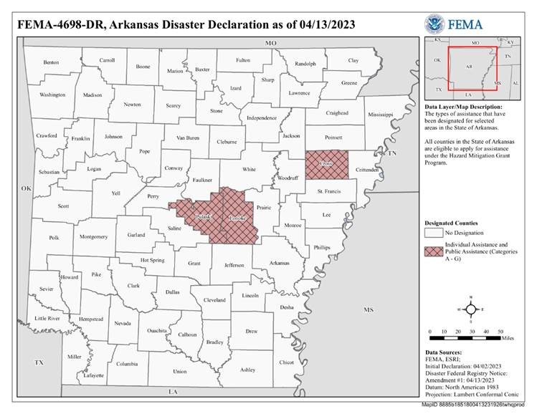
The table below breaks down the obligated FEMA Public Assistance (PA) allocation as of March 25, 2025:
Table 3: DR-4698 Public Assistance
Public Assistance | Obligated Amount
Emergency Work (Categories A-B) | $43,410,165
Permanent Work (Categories C-G) | $13,550,779
Total Public Assistance (PA) | $59,260,484
May 2024 Event: Between May 24 to May 27, 2024, Arkansas experienced severe storms, straight line winds, tornadoes, and flooding across the northern counties of the state. Seventeen tornadoes touched down on May 26, 2024, and while most were rated EF0/EF1, some were rated EF3, with winds of 140 MPH. This was the highest number of tornadoes recorded in a single day since April 25, 2011. Ten fatalities were reported in total, with half of the casualties directly related to tornadoes in Boone, Marion, and Baxter Counties. This was the deadliest disaster in the state since 2014. Severe storms and high winds, coupled with the rainfall earlier in the week, led to flooding and downed trees across the state. By the end of the disaster event, more than 120,000 households were without power. As of May 31, 2024, at least 300 homes were confirmed to be damaged or destroyed.
A presidential declaration of disaster was issued on May 30, 2024, designating the event as DR-4788. This declaration allowed residents of eight counties (Baxter, Benton, Boone, Fulton, Greene, Madison, Marion, and Randolph) to apply for FEMA IA. In total, 2,284 individuals were approved for a total of $8,149,911 in assistance. The table below from FEMA breaks down the approved IA funding as of June 12, 2025:
Table 4: DR-4788 Individual Assistance
Individual Assistance | Approved Amount
Total Housing Assistance (HA) | $4,356,267
Total Other Needs Assistance (ONA) | $3,793,644
Total Individual & Household Program | $8,149,911
Individual Assistance Applications Approved | 2,284

In addition to FEMA IA, the declaration extended PA to state, local, and tribal governments (along with select non-profits) in seven of the eight counties eligible for IA (Baxter, Benton, Boone, Fulton, Madison, Marion, Randolph) along with three additional counties: Caroll, Sharp and Nevada. Greene County was eligible for IA but not PA. The map below displays counties designated for both FEMA IA and PA:

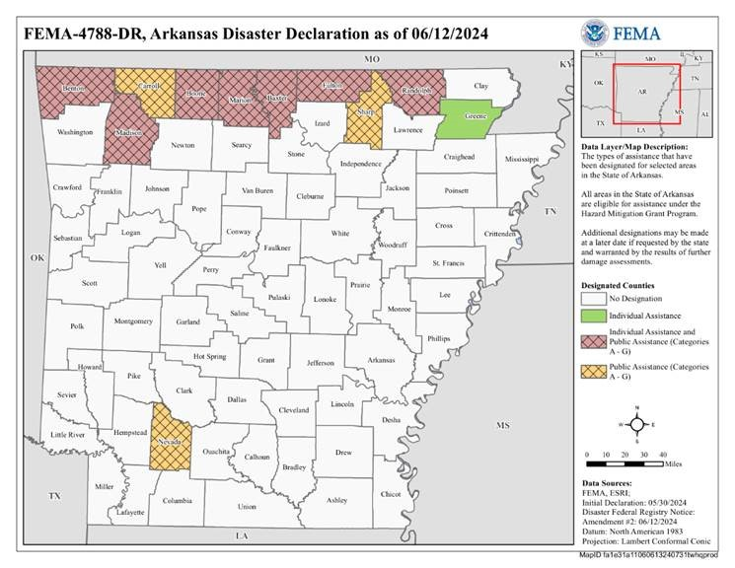
Figure 2: FEMA IA and PA Designated Counties

Most Impacted and Distressed (MID) Areas

HUD identified MID Areas
Grantees are required to use at least 80 percent of their CDBG-DR award to benefit the HUD-identified MID areas. For Arkansas, this would equate to $47,238,400. HUD encourages all grantees to consider using 100 percent of their award to benefit HUD-identified MID areas since the data from these areas is used to determine the award amount. The MID area for DR-4698 and DR-4788 is limited to Benton (ZIP code 72756), Cross, and Pulaski Counties. The Grantee is permitted to expand the HUD MID area to encompass the entire county even if only a ZIP code has been identified. Therefore, Arkansas Development Finance Authority (ADFA) has elected to make the entirety of Benton County a HUD MID county. It has also been decided to exclude the City of Little Rock from Pulaski County, as the city received its own allocation.

Overview of the Impacts of the Qualifying Disaster
Based on news reports from the time of the qualifying disasters, the major disaster impacts center around housing and infrastructure. Between both disaster events, over 3,000 structures were damaged or destroyed and over 180,000 were left without power as a result of the damage. These historically severe events and their impacts to 14 of the State’s 75 counties created significant adverse effects across the state.
Severe tornadoes are particularly devastating for homes, with mobile home units (MHUs) being especially vulnerable at high windspeeds. The image below shows the destruction of a home in Boone County in May 2024 as a result of an EF3-rated tornado.
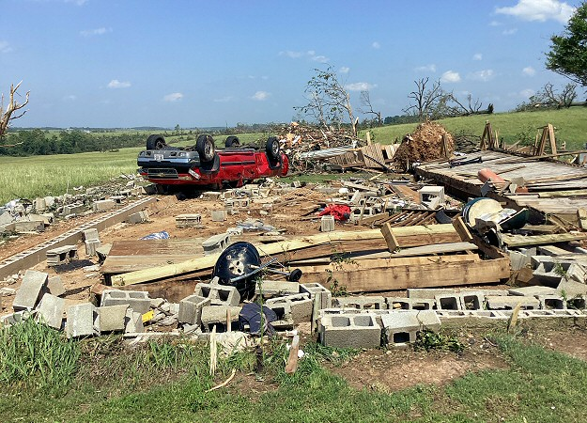
Figure 3: NWS Little Rock, AR – Destructive Tornadoes on March 31, 2023

Source: NWS Little Rock, AR - Severe Storms on May 21-26, 2024
Satellite imagery from the time of the events demonstrates the amount of devastation communities experienced. The image below, captured through satellite and aerial photography following the March 2023 disaster, shows apartment buildings in Pulaski County that were severely damaged or completely destroyed.

Figure 4: NWS Little Rock, AR – Damaged and Destroyed Pulaski Apartment Buildings
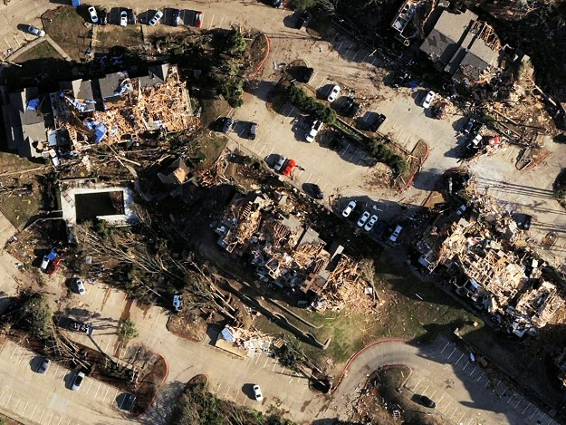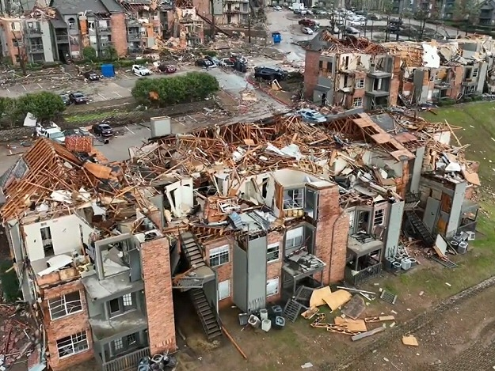
Source: NWS Little Rock, AR - Destructive Tornadoes on March 31, 2023

The tables below provide an overview of the eligible disasters and federal allocations.
Table 5: Disaster Overview
Disaster Summary
Qualifying Disaster: | DR-4698, DR-4788
HUD-identified MID Areas: | Benton, Cross, and Pulaski Counties
Grantee-Identified MID Areas: | N/A

Table 6: CDBG-DR Allocation Overview
CDBG-DR Allocation Overview:
CDBG-DR Allocation: | $51,346,000
CDBG-DR Mitigation Set Aside: | $7,702,000
Total Allocation: | $59,048,000

2
Unmet Needs and Mitigation Needs Summary

Unmet Needs and Mitigation Needs Summary

Unmet Needs and Proposed Allocations
Table 7: Unmet Needs and Proposed Allocations
Eligible Cost Category | Unmet Need | % of Unmet Need | % of Funding to be Expended in HUD Identified MID | CDBG-DR Allocation Amount | % of CDBG-DR Allocation
Administration  (5% cap) | N/A | N/A | N/A | $2,952,400 | 5%
Planning  (15% cap) | N/A | N/A | 0% | $1,000,000 | 1%
Rental  Housing | $31,465,040 | 17% | 100% | $29,000,000 | 49%
Owner-Occupied Housing | $122,642,615 | 65% | 100% | $20,000,000 | 34%
Infrastructure | $26,502,776 | 14% | 100% | $6,095,600 | 11%
Economic Revitalization | $8,457,975 | 4% | 0% | $0 | 0%
Public Service  (15% cap and no cap) | $0 | 0% | 0% | $0 | 0%
Total | $189,068,406 | 100% | 0% | $59,048,000 | 100%
Funds that have not been allocated: |  |  |  | $0 | 0%

3
Unmet Needs Assessment

Unmet Needs Assessment
The information collected through the unmet recovery and mitigation needs assessment process serves as the foundation for the State’s Community Development Block Grant – Disaster Recovery (CDBG-DR) program funding and prioritization decisions.
To prepare for the unmet needs assessment, the ADFA consulted with and drew on data from the following sources:
- U.S. Department of Housing and Urban Development (HUD)
- Federal Emergency Management Agency (FEMA)
- U.S. Army Corps of Engineers (USACE)
- Small Business Administration (SBA)
- U.S. Census Bureau
- U.S. National Oceanic and Atmospheric Administration (NOAA)
- Local Governments
The data gathered allows ADFA to identify and prioritize critical unmet needs for long-term community recovery in the impacted areas. The quality of the assessment is directly tied to the quality and completeness of the data that is available. The assessment attempts to consider work already accomplished for the recovery and community goals. The assessment allows ADFA to design recovery programs that are responsive to the actual remaining needs on the ground.
This section presents the State’s Unmet Needs Assessment, focusing on four sectors as required for the analysis: housing, infrastructure, economic revitalization, and public services. The Unmet Needs Assessment includes a review of housing needs, emphasizing damaged residential properties, particularly among low- and moderate-income (LMI) households. Infrastructure assessments highlight damage to critical public facilities and transportation systems, all essential to community resilience. Economic impacts in the assessment reveal challenges faced by local businesses and workforce disruptions, underscoring the need for economic recovery efforts.
Table 7: Quantified Disaster Impacts and Exacerbated Pre-Existing Needs of Housing, Infrastructure, Economic Development, Other Financial Assistant and Remaining Unmet Need displays an overview of the direct/indirect needs, financial assistance budgeted and obligated to those needs, and the remaining unmet need across seven major cost categories. The table highlights housing and infrastructure as the greatest unmet needs. As such, Arkansas should prioritize funding for new construction housing (rental and single family) and infrastructure support (including FEMA match), to ensure a comprehensive and effective recovery process.
Table 8: Quantified Disaster Impacts and Exacerbated Pre-Existing Needs of Housing, Infrastructure, and Economic Development, Other Financial Assistance, and Remaining Unmet Need
Cost Categories | A  Direct and Indirect Need | B  Financial Assistance Budgeted and Obligated | A-B  Unmet Need
Emergency Shelters, Interim, and Permanent Housing | $0 | $0 | $0
Rental Housing | $38,533,496 | $7,068,456 | $31,465,040
Owner-Occupied Housing | $133,538,577 | $10,895,962 | $122,642,615
Public Housing and Other Affordable Housing | $0 | $0 | $0
Infrastructure | $133,645,434 | $107,142,658 | $26,502,776
Economic Development | $45,121,733 | $36,663,758 | $8,457,975
Public Service | $0 | $0 | $0
Total | $350,839,240 | $161,770,834 | $189,068,406

Housing
This housing needs assessment utilizes public data from FEMA, SBA, housing, and census sources. This assessment identifies the disaster-imposed needs for rehabilitation, reconstruction, or relocation of housing stock, as well as necessary repairs and upgrades to impacted infrastructure to help communities recover.
According to the Northwest Arkansas Council’s website, Northwest Arkansas is the 18th fastest-growing metropolitan area in the U.S., growing each day by an approximately 36 people (or 252 people per week). The Council predicts that the population will reach one million by 2050. While this growth is positive for the booming economy, it also brings challenges such as rising housing costs, traffic congestion, and physical infrastructure issues, all which threaten the quality of life for residents. This data underscores the importance of investing CDBG-DR funds into new housing construction for both single and multi-family units.
To provide additional context for the housing recovery unmet need, the state-wide median home sale price has steadily risen over the past five years, including in the MID counties (Benton, Cross, and Pulaski). Following the disasters in March 2023 and May 2024, there was a brief uptick in the median home sale price in Cross County. This can be partly attributed to a lower supply due to damage and increased demand, which pushed housing prices higher for properties with and without damage.
The most dramatic increase can be seen in Benton County, where the median home sale price has roughly doubled since 2019. Table 8: Median Home Sale Price (2019-2025) below illustrates this trend.
Figure 5: Median Home Sale Price (2019 – 2025)
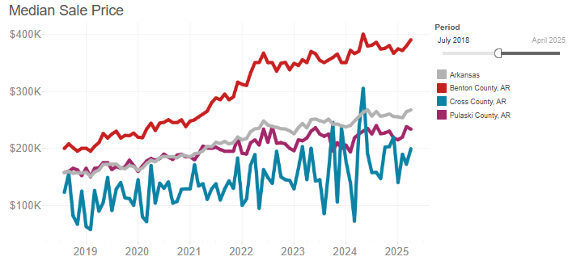
Reference: Redfin Monthly Housing Market Data
Below, Table 9: MID Population and Housing Units displays the populations of each of the MID counties (Benton, Cross, and Pulaski counties) according to the most recent and available U.S. Census data. Cross County has a much lower population and number of housing units than the other two MID counties. The available number of housing units in each county provides context for the rate of damage reported in later FEMA IA data tables.
Table 9: MID Population and Housing Units
MID County | Total Population | Housing Units
Benton | 321,566 | 131,867
Cross | 16,194 | 7,553
Pulaski | 401,209 | 195,885
Source: U.S. Census Bureau QuickFacts: Arkansas
While FEMA Individual Assistance (IA) provided direct support to affected households, it does not address structural rehabilitation or replacement of rental units. Therefore, the unmet rental housing need remains significant and is addressed through targeted CDBG-DR programming.
ADFA also reviewed current housing market conditions within the HUD-designated Most Impacted and Distressed (MID) areas. Market information indicates that housing inventory has increased in portions of the MID area, particularly within Benton and Pulaski Counties, creating opportunities to address housing recovery needs through existing homes available for purchase rather than financing additional residential development. While housing availability and affordability continue to vary across impacted communities, ADFA determined that leveraging existing housing inventory provides a more efficient and cost-effective approach to meeting the identified housing need exacerbated by the disaster. Utilizing existing housing inventory provides an opportunity to address the same unmet housing need more efficiently through direct homeownership assistance, while allowing available funding to assist a greater number of eligible households. Existing housing inventory provides an opportunity to address the same unmet housing need by providing and encouraging the purchase of more resilient housing through direct homeownership assistance, while also allowing available funding to assist a greater number of eligible households.
To better address these conditions, APA 1 replaces the Single-Family New Construction Program with a Homebuyers Assistance Program. While the State continues to identify a significant unmet need for affordable owner-occupied housing, ADFA determined that providing direct assistance to eligible homebuyers is a more effective use of available CDBG-DR funds by maximizing the number of assisted households in effected communities than financing the construction of new housing units. Analysis conducted during program development found that new construction would require substantial subsidy to achieve affordability for low- and moderate-income households and may not as effectively impact the communities.

Rental and Owner-Occupied Single Family and Multifamily Housing
The data in Table 10: FEMA IA Owner-Occupied Applicants demonstrates the impact and assistance received by homeowners in various Arkansas counties affected by DR-4698 and DR-4788. It displays the number of FEMA applicants, inspections, and the extent of damage and FEMA assistance across different counties in Arkansas.
The three MID counties (Benton, Cross, and Pulaski) had the highest numbers of total FEMA verified loss across all counties. The total owner-occupied FEMA-verified loss for Benton County amounted to $10,410,679, with an average verified loss of $2,644 per applicant, highlighting homeowners’ financial burden. A total of 1,355 homes were inspected and found to be damaged, highlighting the extensive need for housing support in the area. The approval of 1,318 applicants for assistance further underscores the urgent demand for recovery resources.
Cross County, despite its lower population and application numbers, had the highest total FEMA verified loss at $47,921,101, accounting for over 70% of the verified loss across all eleven IA-eligible counties. While there were fewer approved Cross County applicants (396) than in Benton County (1,318) and Pulaski (812), the average verified loss in Cross was notably higher, with an average of $9,803 per applicant. This suggests that the damage to homes in Cross County was more severe, requiring more extensive repairs or complete reconstruction. This higher average loss indicates that FEMA IA funds received may not be sufficient to meet the needs of residents, especially for homes that are beyond repair. Pulaski County, which has the highest population of the three MID areas, has the lowest average FEMA verified loss amongst owner-occupied applicants at $1,743. A key insight from Table 9: MID Population and Housing Stock is that 1,639 out of Cross County’s 7,553 total housing units submitted applications for FEMA Individual Assistance. This means that 21.7% of all housing units were affected—highlighting that more than one in five households in the county experienced disaster-related impacts.

Table 10: FEMA IA Owner-Occupied Applicants
County | # of  Applicants | # of  Inspections | # Inspected  With Damage | # Received  Assistance | Total FEMA  Verified Loss | Average FEMA  Verified Loss
Benton (MID) | 3,937 | 1,656 | 1,355 | 1,318 | $10,410,679 | $2,644
Cross (MID) | 808 | 340 | 256 | 396 | $47,921,101 | $9,803
Pulaski (MID) | 2404 | 593 | 300 | 812 | $4,191,264 | $1,743
Lonoke | 106 | 51 | 22 | 23 | $322,079 | $3,038
Greene | 27 | 11 | 8 | 7 | $10,478 | $388
Baxter | 399 | 219 | 179 | 177 | $2,405,174 | $6,028
Boone | 96 | 44 | 32 | 32 | $580,371 | $6,045
Madison | 50 | 34 | 30 | 29 | $246,260 | $4,925
Fulton | 35 | 21 | 19 | 16 | $179,673 | $5,133
Marion | 187 | 108 | 87 | 85 | $1,408,972 | $7,535
Randolph | 25 | 18 | 11 | 9 | $53,754 | $2,150
TOTAL | 8,074 | 3,095 | 2,299 | 2,904 | $67,729,805 | $49,432
Reference: FEMA IA Dataset June 2025
Similarly, Table 11: FEMA IA Tenant Applicants displays a overview of Arkansas tenants affected by both disasters. Pulaski County had the highest number of tenant FEMA applicants who received assistance (1,894 out of 4,973). Pulaski County reported a significantly higher FEMA-verified loss than other counties, including the two additional MIDs—Benton and Cross. The total verified loss in Pulaski reached $1,610,835, with an average of $324 per applicant. While Pulaski’s average verified loss per applicant was not as high as other counties, the application total was significantly higher (365% higher) than Benton’s tenant application rate (1,362). Pulaski County’s total verified loss was the lowest amongst the three MID counties for homeowners ($4,191,264), but the highest for renters, at $1,610,835. Although renter demand for the program was high in Pulaski County, their average verified loss was just 18.6% of that reported by owner-occupied applicants. This suggests that renters experienced more widespread housing damage, but it was generally less severe.
Data from Table 10 (FEMA IA Owner-Occupied Applicants) and Table 11 (FEMA IA Tenant Applicants) shows that the most severe damage occurred in the MID counties, especially in Cross County. Although Cross had fewer approved applicants, likely due to its smaller population, the average verified loss for both homeowners and renters was more than twice that of the other MID counties. In contrast, Benton County had a comparable number of approved tenant applicants, but a much lower average verified loss of $306, indicating that rental housing damage there was less severe.
Table 11: FEMA IA Tenant Applicants
County | # of  Applicants | # of  Inspections | # Inspected  With Damage | # Received  Assistance | Total FEMA  Verified Loss | Average FEMA  Verified Loss
Benton (MID) | 1,362 | 930 | 412 | 559 | $416,925 | $306
Cross (MID) | 821 | 574 | 258 | 461 | $859,624 | $1,047
Pulaski  (MID) | 4,973 | 2,900 | 716 | 1,894 | $1,610,835 | $324
Lonoke | 78 | 43 | - | 0 | $4,352 | $56
Greene | 6 | 5 | 2 | 10 | $2,102 | $350
Baxter | 59 | 40 | 2 | 2 | $24,800 | $420
Boone | 26 | 20 | 21 | 22 | $45,964 | $1,768
Madison | 5 | 4 | - | 0 | $8,704 | $1,741
Fulton | 3 | 1 | - | 0 | $5,802 | $1,934
Marion | 31 | 22 | 9 | 11 | $19,831 | $640
Randolph | 7 | 5 | 1 | 3 | $600 | $86
TOTAL | 7,371 | 4,544 | 1,421 | 2,962 | $2,999,539 | $8,672
Reference: FEMA IA Dataset June 2025
Table 12: Total FEMA IA Application Numbers by County displays application and application approval rates for homeowners and renters who applied for FEMA IA in the MID counties. Out of the 1,629 Cross County households that applied with various levels of damage, only 857 applications (52.6%) were approved. Approximately 47.4% of Cross County residents affected by disaster damage have not received FEMA assistance. While this may not seem high, Cross County actually has the highest FEMA application approval rate among MID counties at 52.6%. In comparison, Benton and Pulaski counties have lower approval rates—35.4% and 36.7%, respectively. Given their much larger populations, it's expected that these counties would have more applications overall. However, the data still points to a substantial number of residents in Benton and Pulaski with unmet recovery needs.

Table 12: Total FEMA IA Application Numbers by County
MID County | Applications: Tenants |  | Applications: Owner-Occupied | Total Applications | Total Received Assistance | % Received Assistance
Benton |  | 1,362 | 3,937 | 5,299 | 1,877 | 35.4%
Cross |  | 821 | 808 | 1,629 | 857 | 52.6%
Pulaski |  | 4,973 | 2,404 | 7,377 | 2,706 | 36.7%
Reference: FEMA IA Dataset June 2025
The data in both Table 13: FEMA IA Applications by Housing Type Total and Table 14: FEMA IA Applications by Housing Type by County provides a breakdown of the number of FEMA IA applications by housing type. Below, Table 13 contains data across various counties in Arkansas. The table categorizes the applications into different residence types, including apartments, condos, houses/duplexes, mobile homes, townhouses, and travel trailers. These tables also display the percentages of ownership categories relative to housing type, for example, in Table 13: FEMA IA Applications by Housing Type Total displays that 86.24% of all owners and 42.87% of all renters reside in houses/duplexes. Approximately 65.46% of all applicants resided in a house or duplex, indicating that houses/duplexes are the structure type that was most impacted by these disasters.
Table 13: FEMA IA Applications by Housing Type Total
Housing Type | No. of Applicants | % Owner Occupied | % Tenants | % Unknown | % Type
Apartment | 3,057 | 0.01% | 41.36% | 11.48% | 19.71%
Assisted Living Facility | 35 | 0.00% | 0.47% | 0.00% | 0.23%
Boat | 4 | 0.04% | 0.00% | 1.64% | 0.03%
Condo | 126 | 0.92% | 0.69% | 1.64% | 0.81%
House/Duplex | 10,150 | 86.24% | 42.87% | 44.26% | 65.46%
Mobile Home | 852 | 7.18% | 3.62% | 8.20% | 5.49%
Other | 793 | 3.62% | 6.53% | 32.79% | 5.11%
Townhouse | 332 | 0.53% | 3.92% | 0.00% | 2.14%
Travel Trailer | 155 | 1.46% | 0.50% | 0.00% | 1.00%
Military Housing | 2 | 0.00% | 0.03% | 0.00% | 0.01%
Reference: FEMA IA Dataset June 2025
Table 14: FEMA IA Applications by Housing Type by County provides a breakdown of the number of FEMA IA applications by housing type for each HUD MID county.
Benton County had the highest proportion of affected homes classified as houses or duplexes, with 81% of applicants residing in these structures—compared to 66% in Cross County and 54% in Pulaski. Among owner-occupied applicants in Benton, 89.38% lived in a house or duplex. Apartments were the next most common structure type, but they accounted for less than 6% of Benton’s total applicants (313 individuals). In Cross County, 66% of applicants live in houses or duplexes. Apartments made up 15% of applicants, closely followed by mobile homes at 14%. Pulaski County received the highest number of applications overall (7,401). Of these, 53.76% were from residents in houses or duplexes (3,979), while 2,464 applicants—over 33%—lived in apartments. This is notably higher than the apartment residency rates in Benton (6%) and Cross (15%).
Across all three MID counties, houses and duplexes represented the dominant structure type, accounting for more than 65% of applicants. Apartments were the second most common but made up only 21% of total applicants across Benton, Cross, and Pulaski.
Table 14: FEMA IA Applications by Housing Type by County
MID County | Residence Type | No. of Applicants | % Owner Occupied | % Tenants | % Unknown | % Type
Benton | Apartment | 313 | 0.00% | 22.98% | 0.00% | 5.89%
Benton | Assisted Living Facility | 6 | 0.00% | 0.44% | 0.00% | 0.11%
Benton | Boat | 3 | 0.05% | 0.00% | 6.67% | 0.06%
Benton | Condo | 15 | 0.20% | 0.51% | 0.00% | 0.28%
Benton | House/Duplex | 4,312 | 89.38% | 57.49% | 66.67% | 81.14%
Benton | Mobile Home | 264 | 5.38% | 3.82% | 0.00% | 4.97%
Benton | Other | 285 | 3.45% | 10.65% | 26.67% | 5.36%
Benton | Townhouse | 47 | 0.18% | 2.94% | 0.00% | 0.88%
Benton | Travel Trailer | 69 | 1.35% | 1.17% | 0.00% | 1.30%
Total |  | 5,314
Cross | Apartment | 252 | 0.00% | 30.57% | 10.00% | 15.38%
Cross | Condo | 1 | 0.00% | 0.12% | 0.00% | 0.06%
Cross | House/Duplex | 1,087 | 80.07% | 53.11% | 40.00% | 66.32%
Cross | Mobile Home | 229 | 16.21% | 11.69% | 20.00% | 13.97%
Cross | Other | 53 | 3.22% | 2.92% | 30.00% | 3.23%
Cross | Townhouse | 13 | 0.00% | 1.58% | 0.00% | 0.79%
Cross | Travel Trailer | 4 | 0.50% | 0.00% | 0.00% | 0.24%
Total |  | 1,639
Pulaski | Apartment | 2,464 | 0.04% | 49.41% | 25.00% | 33.29%
Pulaski | Assisted Living Facility | 29 | 0.00% | 0.58% | 0.00% | 0.39%
Pulaski | Condo | 104 | 2.58% | 0.82% | 4.17% | 1.41%
Pulaski | House/Duplex | 3,979 | 88.94% | 36.84% | 37.50% | 53.76%
Pulaski | Mobile Home | 134 | 2.50% | 1.47% | 4.17% | 1.81%
Pulaski | Other | 383 | 3.58% | 5.83% | 29.17% | 5.17%
Pulaski | Townhouse | 265 | 1.33% | 4.69% | 0.00% | 3.58%
Pulaski | Travel Trailer | 41 | 1.04% | 0.32% | 0.00% | 0.55%
Pulaski | Military Housing | 2 | 0.00% | 0.04% | 0.00% | 0.03%
Total |  | 7,401
Reference: FEMA IA Dataset June 2025
In Table 15: FEMA Real Property Damage – Owner Units, the data for owner-occupied units informs us about the extent of damage and the number of affected properties across various Arkansas counties. The MID counties contain the vast majority (88.5%) of damaged owner-occupied units across the state. Benton County has the highest number of damaged units, totaling 3,937 properties, or 48.8% of all damaged owner-occupied units. An overwhelming number of these properties (83.8%) experienced only minor-low grade damage. Pulaski County, with the second highest total number of units damaged (2,404), experienced a similar distribution of damage, with 92.3% of all units reporting only minor-low damage. Cross County reported the highest number of units that experienced major-low, major-high, and severe damage. Although these units did not represent the majority of reported damage, they accounted for nearly 16% of affected structures in Cross County. In comparison, similar units made up only 7.5% of reported damage in Benton County and 3.6% in Pulaski County. This suggests that, despite having fewer total units impacted, Cross County experienced more severe damage relative to its size.
Table 15: FEMA Real Property Damage– Owner Units
County | Major-High | Major-Low | Minor-High | Minor-Low | Severe | Total
Benton (MID) | 48 | 210 | 342 | 3,301 | 36 | 3,937
Cross (MID) | 24 | 66 | 70 | 609 | 39 | 808
Pulaski (MID) | 17 | 50 | 99 | 2,219 | 19 | 2,404
Lonoke | 0 | 4 | 10 | 91 | 1 | 106
Greene | 0 | 0 | 1 | 26 | 0 | 27
Baxter | 13 | 33 | 55 | 290 | 8 | 399
Boone | 1 | 6 | 8 | 78 | 3 | 96
Madison | 2 | 4 | 5 | 38 | 1 | 50
Fulton | 2 | 3 | 8 | 21 | 1 | 35
Marion | 7 | 17 | 19 | 137 | 7 | 187
Randolph | 1 | 1 | 1 | 22 | 0 | 25
Total | 115 | 394 | 618 | 6,832 | 115 | 8,074
Reference: FEMA IA Dataset June 2025
In Table 16: FEMA Real Property Damage – Rental Units, we see notable differences from the owner-occupied data. While Benton reported the highest number of damaged owner-occupied units, 67.5% of the damaged rental units in the state are located in Pulaski County. The vast majority of rental units across all counties experienced minor-low grade damage. Once again, 97% of damaged rental units are located within the three MID counties.
Table 16: FEMA Real Property Damage– Rental Units
County | Major-High | Major-Low | Minor-High | Minor-Low | Severe | Total
Benton (MID) | 20 | 26 | 43 | 1,265 | 8 | 1,362
Cross (MID) | 43 | 44 | 36 | 659 | 39 | 821
Pulaski (MID) | 164 | 78 | 143 | 4,565 | 23 | 4,973
Lonoke | 1 | 0 | 0 | 77 | 0 | 78
Greene | 0 | 0 | 1 | 5 | 0 | 6
Baxter | 3 | 1 | 2 | 53 | 0 | 59
Boone | 2 | 1 | 0 | 21 | 2 | 26
Madison | 0 | 0 | 0 | 4 | 1 | 5
Fulton | 1 | 0 | 0 | 2 | 0 | 3
Marion | 3 | 1 | 0 | 27 | 0 | 31
Randolph | 0 | 0 | 0 | 7 | 0 | 7
Total | 237 | 151 | 225 | 6,685 | 73 | 7,371
Reference: FEMA IA Dataset June 2025
The data from Table 17: Homeowners with Flood Insurance by county reveals a lack of flood insurance coverage among homeowners across various counties, leaving them particularly vulnerable after DR-4788. Of the 8,074 FEMA Individual Assistance applicant homeowners, a staggering 7,977—representing 98.80%—did not have flood insurance. Only 97 applicants (1.20%) had coverage. In the MID-designated areas, flood insurance coverage was similarly scarce:
- Benton County: 98.75% of residents lacked flood insurance
- Cross County: 98.64% lacked coverage
- Pulaski County: 99.04% lacked coverage
These figures highlight a critical vulnerability—residents in these counties were overwhelmingly uninsured, leaving them without a vital resource for recovery after flooding events.
Table 17: Homeowners with Flood Insurance by County
County | Homeowners without Flood Insurance | Percentage of Total without Flood Insurance | Homeowners with Flood Insurance | Percentage of Total with Flood Insurance | Total Homeowners
Benton (MID) | 3,888 | 98.75% | 49 | 1.25% | 3,937
Cross (MID) | 797 | 98.64% | 11 | 1.36% | 808
Pulaski (MID) | 2,381 | 99.04% | 23 | 0.96% | 2,404
Lonoke | 106 | 100% | 0 | 0% | 106
Greene | 25 | 92.59% | 2 | 7.41% | 27
Baxter | 390 | 97.74% | 9 | 2.26% | 399
Boone | 95 | 98.96% | 1 | 1.04% | 96
Madison | 50 | 100% | 0 | 0% | 50
Fulton | 34 | 97.14% | 1 | 2.86% | 35
Marion | 186 | 99.47% | 1 | 0.53% | 187
Randolph | 25 | 100% | 0 | 0% | 25
Total | 7,977 |  | 97 |  | 8,074
Reference: FEMA IA Dataset June 2025
The data from Table 18: Owner-Occupied Units with and without Flood Insurance by Income provides insights into the distribution of flood insurance coverage among owner-occupied units across different income categories. Out of 8,074 homeowners, there are incredibly limited rates (less than 0.5%) of flood insurance policy holders across all income categories.
Table 18: Owner-Occupied Units with and without Flood Insurance by Income
Income Category | Homeowners without Flood Insurance | Percentage of Total without Flood Insurance | Homeowners with Flood Insurance | Percentage of Total with Flood Insurance | Total Homeowners
No Stated Income | 896 | 11.10% | 13 | 0.16% | 909
<$15,000 | 543 | 6.73% | 8 | 0.10% | 551
$15,000-$30,000 | 1,157 | 14.33% | 9 | 0.11% | 1,166
$30,001-$60,000 | 2,034 | 25.19% | 25 | 0.31% | 2,059
$60,001-$120,000 | 2,053 | 25.43% | 25 | 0.31% | 2,078
$120,001-$175,000 | 700 | 8.67% | 6 | 0.07% | 706
>$175,000 | 594 | 7.36% | 11 | 0.14% | 605
Grand Total | 7,977 | 98.81% | 97 | 1.20% | 8,074
Reference: FEMA IA Dataset June 2025
The National Flood Insurance Program (NFIP) is a federally funded and managed insurance program. Because enrollment is voluntary, NFIP claims do not represent all flood-affected households—but they do offer insight into the scale of flood damage after a disaster. As table 19: NFIP Payments by County illustrates, Pulaski County, the most populous of the MID counties, received the highest number of NFIP payments. However, these figures should not be confused with the number of homeowners and renters who applied for FEMA Individual Assistance (IA).

Table 19: NFIP Payments by County
MID County | # of Homeowners | Average Insured Amount (for Building) | Payment (for Building) | Average Insured Amount (for Contents) | Payment (for Contents)
Benton | 702 | $222,581 | $110,949.73 | $52,816 | $3,972
Cross | 117 | $107,983 | - | $16,846 | -
Pulaski | 2,193 | $203,302 | - | $48,600 | -
Grand Average | 1,004 | $177,955 | $110,949.73 | $39,421 | $3,972
Reference: NFIP data files from FEMA A000N3, A000Y2, and A000Y3
Manufactured housing units can be particularly susceptible to severe wind and tornado events like those experienced in the two disaster declarations. Table 20: Manufactured Housing Units Impacted by Disaster reveals varying degrees of impact on manufactured housing units across counties. Cross County experienced the highest rate of impact, reporting damage on 19.69% of all MHUs in the county. With nearly one in five MHU households impacted, it can be assumed that MHU parks experienced widespread damage in Cross County. In total, there is $1,539,894 remaining in unmet need from MHUs in Cross County alone. While the other MID counties (Benton and Pulaski) experienced a high rate of damage to houses/duplexes in comparison to other counties across the state, their rates of damage (6.77% and 1.71% respectively) to MHU units were less than the proportion of units damaged in Cross County.
Owners of manufactured homes frequently encounter financial challenges when their properties are damaged. This analysis highlights the urgent need for targeted disaster recovery efforts focused on manufactured housing units, especially in the most heavily impacted areas. Notably, 73.5% of the remaining unmet needs for these units are concentrated in the MID counties.
Table 20: Manufactured Housing Units Impacted by Disaster
County | Unmet Need | # of Total Units | % of Total Units in County
Benton (MID) | $905,854 | 264 | 6.77%
Cross (MID) | $1,539,894 | 229 | 19.69%
Pulaski (MID) | $- | 134 | 1.71%
Lonoke | $120,100 | 49 | 1.31%
Baxter | $33,293 | 82 | 3.64%
Boone | $296,045 | 14 | 1.09%
Madison | $190,619 | 13 | 1.02%
Fulton | $66,367 | 4 | 0.38%
Marion | $194 | 56 | 4.40%
Randolph | $- | 7 | 0.82%
Grand Total | $3,491,759 | 852 | Grand Average: 4.08%
Reference: FEMA IA Dataset June 2025

Total Home Loans Approved by SBA
Table 21: Total Disaster Home Loans Approved by SBA illustrates a clear concentration of need within the MID counties, accounting for nearly 93% of all loans. The total verified loss across all counties is lower than the current SBA loan amount, especially in Cross and Pulaski counties, where the loan amount only makes up for 36% and 38% of the respective total verified loss.
Table 21: Total Disaster Home Loans Approved by SBA
County | # of Home Loans | Total Verified Loss | Current Loan Amount | Loan Amount Disbursed
Baxter | 15 | $2,616,987 | $1,026,081 | $993,719
Benton (MID) | 178 | $15,958,253 | $9,896,947 | $9,095,689
Boone | 4 | $364,355 | $333,700 | $333,700
Cross (MID) | 66 | $10,307,295 | $3,755,400 | $3,755,400
Lonoke | 3 | $211,728 | $114,600 | $114,600
Madison | 1 | $- | $25,000 | $25,000
Marion | 10 | $1,216,884 | $800,943 | $741,186
Pulaski (MID) | 170 | $14,766,000 | $5,649,740 | $5,649,740
Grand Total | 447 | $45,441,502 | $21,602,411 | $20,709,034
Reference: SBA Data on Disaster Home Loan Applications – August 2025

Public Housing (Including HUD-assisted Housing) & Other Housing
No public housing authorities (PHAs) reported any damage as a result of the disasters, as displayed by Table 22: Public Housing Agencies (PHAs) Damaged.
Table 22: Public Housing Agencies (PHA)s Damaged
MID County | PHA Name | PHA Code | # of Units | Units Damaged
Cross | Housing Authority of the City of Parkin | AR072 | 60 | 0
Cross | Wynne Housing Authority | AR039 | 70 | 0
Cross | Housing Authority of the City of Hickory Ridge | AR093 | 16 | 0
Benton | Housing Authority of the City of Decatur | AR095 | 0 | 0
Benton | Siloam Springs Housing Authority | AR163 | 0 | 0
Pulaski | Jacksonville Housing Authority | AR170 | 100 | 0
Pulaski | North Little Rock Housing Authority | AR002 | 110 | 0
Pulaski | Housing Authority of the City of Little Rock | AR004 | 334 | 0
Reference: HUD Open Data – Housing and Urban Development, Office of Policy Development and Research - Public Housing Authorities
ADFA surveyed the disaster damage to the units participating in the Low-Income Housing Tax Credit (LIHTC) and HOME Investment Partnerships Program (HOME). As table 23 illustrates, only 11 units were damaged and all damaged units are being repaired using insurance funds. Therefore, there is no reported unmet need for these units within MID counties. Information on housing choice voucher units was not available at the time of drafting this action plan.
Table 23: HUD-Assisted Housing Impacted by Disaster
MID County | Name | Total  Damaged HOME & LIHTC Units | Remaining Unmet Need
Benton | Autumnwood Point, Indian Creek, Gateway, Rogers Apartments | 11 | 0

Emergency Shelters, Interim, and Permanent Housing
HUD annually publishes the Continuum of Care (CoC) Homeless Assistance Programs dashboard reports that show CoC geographic areas and changes in geographic coverage over time. The reports also contain summary data from the Point-in-Time (PIT) count and Housing Inventory Count (HIC), providing an overview of a CoC’s performance in utilizing their CoC awards to serve houseless individuals. Table 24: Affected Continuum of Care (CoC) Entities present homeless counts reported by participating CoC organizations, with data reflecting both MID counties and their grouping alongside non-MID counties.
Table 24: Affected Continuum of Care (CoC) Entities
CoC Number | CoC Entity | Impacted County | Homeless Count
AR-500 | Little Rock/Central Arkansas CoC | Pulaski, Lonoke | 1,016
AR-501 | Fayetteville/Northwest Arkansas CoC | Benton, Carroll, Madison | 412
AR-503 | Arkansas Balance of State CoC | Baxter, Boone, Cross, Fulton, | 820
AR-505 | Southeast Arkansas CoC | -- | 102
AR-508 | Fort Smith CoC | -- | 433
Total |  |  | 2,783
Reference: AR Balance of State - Point in Time Count, HUD CoC Dashboard Reports, HUD 2024 Continuum of Care Homeless Assistance Programs Homeless Populations and Subpopulations
Table 25: Point-in-Time Count – Impacted by Disaster & Type of Shelter illustrates the number of those experiencing housing instability, whether in an emergency shelter, transitional housing, or unsheltered at the time of the disaster. The data reveals that across the state, a total of 5,031 individuals are experiencing housing instability at the time of the disaster, with nearly half (2,473) living unsheltered. FEMA-declared areas account for a significant portion of this population, comprising 2,248 individuals, over 80% of whom are either in emergency shelters or unsheltered. Transitional housing remains the least utilized shelter type statewide, representing just 586 individuals. These figures highlight the need for long-term housing solutions, particularly in disaster-affected regions where vulnerability is heightened.
Table 25: Point-in-Time Count – Impacted by Disaster & Type of Shelter
Geography | Emergency Shelter | Transitional Housing | Unsheltered Homeless | Total Known Homeless
Statewide | 1,114 | 335 | 1,334 | 2,783
FEMA Declared | 858 | 251 | 1,139 | 2,248
Reference: AR Balance of State - Point in Time Count, ADE Data Center - Homeless By Type by County

Infrastructure
FEMA’s Public Assistance Program offers supplemental grants to state, tribal, territorial, and local governments, as well as certain types of private non-profits. This support enables communities to efficiently respond to and recover from major disasters or emergencies. While FEMA provides grant assistance for recovery efforts, it requires a non-federal share amounting to 25% of the project cost. This expense must be covered by the state or local government, which can pose a challenge to already strained resources. Community Development Block Grant Disaster Recovery (CDBG-DR) funds can be utilized to cover the non-federal share pertaining to public facilities.
Table 26: FEMA Public Assistance Program illustrates the breakdown of FEMA Public Assistance (PA) by total cost, federal share, and non-federal share. As is commonly observed with FEMA allocations, the largest single expenditure (50%) was directed towards debris removal, followed by emergency protective measures (20.78%). Additionally, the repair of public facilities represented a significant portion of the cost.

Table 26: FEMA Public Assistance Program
PA Categories | Total Costs | Federal Share Obligated | Non-federal Share Needed
A - Debris Removal | $57,708,607 | $47,622,043 | $10,086,564
B1 - Emergency Protective Measures | $23,961,424 | $19,149,627 | $ 4,811,797
B2 - Emergency Work Donated | $931,795 | $815,111 | $116,684
C - Roads and Bridges | $1,228,384 | $921,288 | $307,096
D - Water Control Facilities | $174,002 | $130,502 | $43,501
E - Buildings and Equipment | $7,009,937 | $5,257,453 | $1,752,484
F - Utilities | $12,021,326 | $9,015,994 | $3,005,331
G - Parks, Recreation & Other Items | $9,074,551 | $6,805,913 | $ 2,268,638
Z - Management Costs | $3,190,919 | $3,190,919 | -
Total | $115,300,945 | $92,908,850 | $22,392,095
Reference: FEMA Public Assistance Dataset, June 2025
Table 27: FEMA Public Assistance by County, displays the HUD MID counties reported the greatest total costs at 83% and need for non-federal share. The data shows an overall fund utilization rate of about 81%, with $115.3M allocated and $92.9M spent. Pulaski, Cross, and Benton counties received the largest shares and maintained strong spending. Most counties hover around 75% utilization, while Lonoke leads with over 93%. The remaining $22.4M offers room for reallocation or program expansion, with targeted support needed to accelerate progress in slower regions
Table 27: FEMA Public Assistance Program by County
County | Total Costs | Federal Share Obligated | Non-federal Share Needed
Baxter County | $4,103,726 | $3,080,599 | $1,023,128
Benton County (MID) | $15,276,098 | $11,462,388 | $3,813,710
Boone County | $489,593 | $367,482 | $122,111
Carroll County | $234,568 | $176,008 | $58,560
Cross County (MID) | $24,036,229 | $19,774,733 | $4,261,496
Fulton County | $123,108 | $92,692 | $30,416
Lonoke County | $337,691 | $314,993 | $22,699
Madison County | $244,554 | $186,191 | $58,363
Marion County | $402,977 | $302,554 | $100,422
Nevada County | $342,157 | $256,618 | $ 85,539
Pulaski County (MID) | $56,538,399 | $45,939,823 | $10,598,576
Randolph County | $322,376 | $242,078 | $80,298
Sharp County | $123,647 | $92,736 | $30,912
Statewide | $12,725,822 | $10,619,956 | $2,105,866
Total | $115,300,945 | $92,908,851 | $22,392,096
Reference: FEMA Public Assistance Dataset, June 2025
FEMA also facilitates the Hazard Mitigation Grant Program (HMGP) to assist in the recovery effort. Table 28: FEMA Hazard mitigation Grant Program by cost, reveals that for Hazard Mitigation, out of the overall total of over $18 million, Pulaski County alone accounts for over $10 million.
Table 28: FEMA Hazard Mitigation Grant Program by Cost
County | Total Costs | Federal Share Obligated | Non-federal Share Needed
Crawford | $1,494,855 | $1,121,141 | $373,714
Cross (MID) | $4,228,084 | $3,171,063 | $1,057,021
Faulkner | $35,000 | $26,250 | $8,750
Lee | $35,000 | $26,250 | $8,750
Phillips | $35,000 | $26,250 | $8,750
Polk | $40,000 | $30,000 | $10,000
Pulaski (MID) | $10,574,788 | $7,931,091 | $2,643,697
Statewide | $1,901,762 | $1,901,762 | N/A
Reference: FEMA Hazard Mitigation Dataset, June 2025
Table 29: FEMA Hazard Mitigation Grant Program by program illustrates that the majority of HMGP funding has gone toward safe room construction which is an eligible CDBG-DR activity.
Table 29: FEMA Hazard Mitigation Grant Program by Project Type
Project Type | Total Costs | Federal Share Obligated | Non-federal Share Needed
Safe Rooms | $15,817,939 | $11,863,454 | $3,954,485
Generators | $479,788 | $359,841 | $119,947
Local Mitigation Plans | $145,000 | $108,750 | $36,250
Management Costs | $1,901,762 | $1,901,762 | N/A
Grand Total | $18,344,489 | $14,233,807 | $4,110,682
Reference: FEMA Hazard Mitigation Dataset, June 2025
ADFA reevaluated anticipated demand and implementation needs for the FEMA non Federal Match program and determined that limiting eligibility to FEMA Public Assistance (PA) projects will better align available CDBG-DR resources with identified recovery and mitigation needs. Public Assistance projects address critical public infrastructure and community facilities that support long-term recovery and resilience in disaster-impacted communities.
Based on further program development and consideration of available funding resources, ADFA determined that including Hazard Mitigation Grant Program (HMGP) activities within the FEMA Non-Federal Match program will not sufficiently align with allocated resources to achieve the program's intended recovery objectives. By focusing available funding on eligible FEMA PA projects, ADFA can provide a more targeted approach to addressing unmet infrastructure and public facility recovery and resilience needs while maintaining consistency with the State's overall recovery strategy. The PA projects should incorporate mitigation measures that reduce the impact of future disasters on the community.

Economic Revitalization
In addition to home loans, the SBA offers disaster loans to businesses to help cover uninsured losses or costs not funded by FEMA. These loans can also be used for everyday operating expenses the business would have been able to pay if the disaster hadn’t happened. SBA business loans approved in the wake of the disaster show a high concentration of need in the MID counties, accounting for nearly 95% of all loans. In both Benton and Pulaski, the total verified loss is greater than the current SBA loan amount, pointing to economic unmet need.
Table 30: Total Business Loans Approved by the SBA
County | # of Business Loans | Total Verified Loss | Current Loan Amount | Loan Amount Disbursed
Baxter | 3 | $135,991 | $72,700 | $72,700
Benton (MID) | 241 | $37,311,543 | $28,970,158 | $20,870,722
Boone | 4 | $1,815,443 | $1,929,000 | $217,800
Cross (MID) | 8 | $150,438.30 | $154,200 | $154,200
Fulton | 2 | $- | $4,200 | $4,200
Lonoke | 1 | $- | $22,100 | $22,100
Marion | 2 | $12,000 | $19,000 | $19,000
McDonald | 4 | $- | $1,106,000 | $1,106,000
Pulaski (MID) | 79 | $5,696,317 | $3,874,800 | $3,874,800
Saline | 2 | $- | $511,600 | $511,600
Grand Total | 346 | $45,121,733 | $36,663,758 | $26,853,122
Reference: SBA Data on Disaster Business Loan Applications – August 2025

Public Services
There is currently no identified unmet need for public services. If ADFA determines that a public service unmet need requiring CDBG-DR funding arises, this section will be revised to reflect that need.

Conclusion
ADFA has taken careful steps to gather, collect, and analyze data from federal, state, and local resources to identify where Arkansans have faced impacts from declared disasters and what types of needs persist. The unmet needs analysis shows remaining unmet need in the areas of housing and infrastructure, especially within the MID areas of Benton, Cross, and Pulaski counties. The data on commercial vacancies and building permits seem to indicate that businesses in the area are recovering.

4
Mitigation Needs Assessment

Mitigation Needs Assessment

Overview
In accordance with HUD guidance, the State of Arkansas completed the following Mitigation Needs Assessment. The State reviewed existing hazard plans, and past Action Plans of the State’s earlier CDBG-DR grants recently approved by HUD, to develop a multi-hazard risk-based Mitigation Needs Assessment. This assessment informs and supports the mitigation activities proposed in this Action Plan, with a focus on addressing and analyzing all significant current and future hazard risks. This mitigation needs assessment analyzes statewide risks with specific sections detailing hazards in the most impacted areas (Benton, Cross, and Pulaski Counties).
There have been forty-one presidentially declared disasters in the State of Arkansas since 2000. The most common natural disasters that cause damages to an extent that results in a federal disaster declaration are severe storms. Since 2000, there have been thirty-one declared severe storm-related disasters (excluding severe winter storms) and ten tornado-related disasters. This historical pattern of extreme weather is expected to continue and become more severe due to increasing hazards. Based on this, mitigation measures to reduce impacts caused by these types of hazards are critical.
Every county in the State has been impacted by one or more of these events and has resulted in the devastating loss of life and hardship of Arkansas residents, forcing many to relocate, exhaust their financial assets and undermine the security of living in their homes or investing in their properties or businesses. Flood loss insurance claims are particularly costly with 5,723 claims totaling over $185,461,057.83 in Arkansas since 1991.

Figure 6: Federal Disaster Declarations Per County 2013-2023
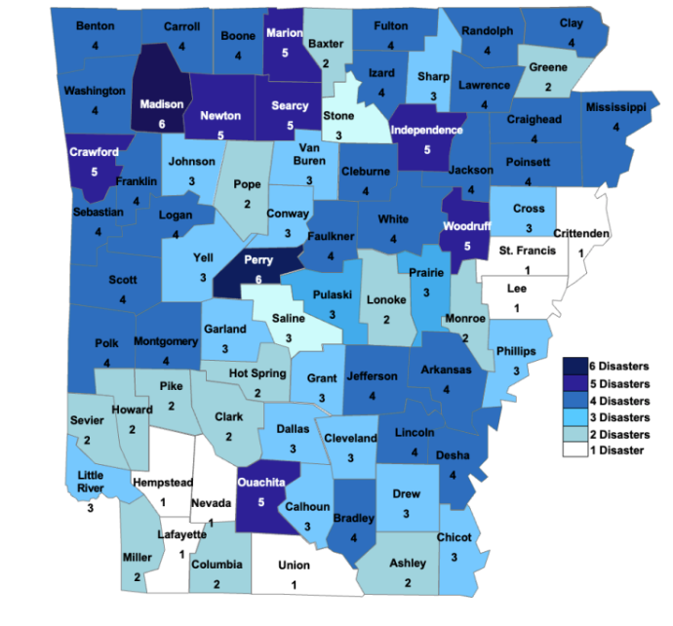
Reference: 2023 State of Arkansas Hazard Mitigation Plan
The most impacted and distressed (MID) counties are Pulaski, Cross, and Benton counties. These are highlighted above within the red squares. The distribution of federal disaster declarations in central and northern regions of the state indicate a pattern of significant disasters. This assessment will provide a basis upon which to propose programs and projects as part of this plan that will mitigate current and future hazards. In addition, it will inform all projects undertaken through CDBG-DR such that, at a minimum, they do not exacerbate natural hazard threats and make use of scarce resources for recovery and mitigation. As part of this assessment, the State also sought to identify and address risks to indispensable services, or those services that enable continuous operation of critical business and government functions, and/or are critical to human health and safety and economic security.

Increasing Hazards
Increasing hazards is a term used to categorize significant variations in expected weather events ranging from extreme temperatures, weather occurrences outside of average date ranges for that specific weather, and weather events not typical for a given geographic location. Arkansas is one of the largest agricultural producing states in the nation. Given the right impact on the climate, this could have a profound impact on not only the economy but also the health and wellbeing of citizens. Projections must account for regional variability, as not all natural disasters are worsening uniformly across the state—and some may not be intensifying at all. To prepare for and mitigate the effects of increasing hazards on Arkansas’ prosperity, culture, and natural resources, planners considering future conditions should take the potential effects of increasing hazards into account.

Greatest Risk Hazards
Analysts identified the ‘greatest risk hazards’ as hazards with the highest damage costs and the highest frequencies of occurrence as designated by the NOAA National Centers for Environmental Information (NCEI) 2025 data.
Table 31: Billion-Dollar Events to Affect Arkansas, 1980-2024 (CPI-Adjusted)
Disaster Type | Events | Events/​Year | Percent Frequency | Total Costs | Percent of Total Costs
Severe Storm | 55 | 1.2 | 56.7% | $10.0B-20.0B | 46.1%
Drought | 17 | 0.4 | 17.5% | $5.0B-10.0B | 26.6%
Winter Storm | 9 | 0.4 | 18.6% | $10B-20B | 25.5%
Flooding | 9 | 0.2 | 9.3% | $2.0B-5.0B | 18.1%
Tropical Cyclone | 5 | 0.1 | 5.2% | $500M-1.0B | 2.8%
Freeze | 2 | 0.0 | 9.3% | $1.0B-$2.0B | 5.2%
All Disasters | 97 | 2.2 | 100.0% | $20.0B-$50.0B | 100.0%
Source: NOAA National Centers for Environmental Information (NCEI) U.S. Billion-Dollar Weather and Climate Disasters (2025).
To align the NCEI data above with the State of Arkansas’ Hazard Mitigation Plan, this action plan will include freeze/extreme cold events within the winter storm hazard profile and separate the tornado hazard profile from the severe storm profile, as this hazard has historical significance and relevance when considering the impacts of DR 4698 and DR 4788. The hurricane/tropical cyclone hazard profile will be included in the ‘Severe Storm’ section, as this hazard type is considered a type of severe storm.

Hazard Probabilities
For many of the natural hazards, the best available data with which to estimate probability is often based on past events. Though certainly not the only source of past event data, a key source for this information comes from the Storm Events Database of the National Centers for Environmental Information (NCEI). NCEI data was analyzed for dam and levee failure, drought, extreme/excessive heat, riverine flooding, flash flooding, winter weather, hail, lightning, tornadoes, and wind. As NCEI information is used for so many hazards, it is important to note the following about the information in the NCEI Storm Events Database:
  - From 1950 through 1954, only tornado events were recorded.
  - From 1955 through 1992, only tornado, thunderstorm, wind, and hail events were keyed from the paper publications into digital data.
  - From 1993 to 1995, only tornado, thunderstorm, wind, and hail events have been extracted from the unformatted text files.
  - From 1996 to present, 48 event types were recorded as defined in NWS Directive 10-1605.

Hazard Profiles

Severe Storm
Severe storms comprise the hazardous and damaging weather effects often found in violent storm fronts. They can occur together or separate, they are common and usually not hazardous, but on occasion they can pose a threat to life and property. This plan defines severe storms as a combination of the following severe weather effects as defined by NOAA and the NWS; hail, high/strong straight-line wind, and lightning. Throughout the state, structures and their contents are vulnerable to damage by thunderstorm winds. Storms, severe or not, are often predicted within a day or multiple days in advance. The severity of a storm is not as easily predicted and when it is, the window of notification is up to a few hours to under an hour. When a storm is imminent, it is unknown whether or not hail, lightning, or damaging winds will occur until after an incident has been reported. Thunderstorms, and the accompanying hail, lightning, and wind, typically last less than an hour. According to NOAA data, Benton County—one of the most impacted and distressed (MID) counties—experiences an average of 0.7 significant lightning strikes per year, or roughly one every other year, and approximately 5.5 significant hailstorms annually. Additionally, Benton County should expect just over seven significant wind events per year or at a rate of 7.18 events per year.

Tropical Cyclone/Hurricane
A tropical cyclone is a warm-core low pressure system, without any front attached, that develops over the tropical or subtropical waters and has an organized circulation. These include hurricanes and typhoons. Tornadoes are related to larger vortex formations and therefore often form in convective cells such as thunderstorms or in the right forward quadrant of a hurricane, far from the hurricane eye. The strength and number of tornadoes are not related to the strength of the hurricane that generates them. Since 2005, there have been three hurricanes in Arkansas that included a disaster declaration, Hurricane Laura (EM-3541-AR) in August 2020, Severe Storms and Flooding associated with Hurricane Gustav (DR-1793-AR) in September 2008, and Hurricane Katrina (EM-3215-AR) in the fall of 2005.

Thunderstorm
A thunderstorm, also known as an electrical storm, a lightning storm, thundershower or simply a storm, is a form of turbulent weather characterized by the presence of lightning and its acoustic effect on the Earth's atmosphere known as thunder. The meteorologically assigned cloud type associated with the thunderstorm is the cumulonimbus. Thunderstorms are usually accompanied by fierce winds, heavy rain and sometimes snow, sleet, hail, or no precipitation at all. Those that cause hail to fall are called hailstorms. Thunderstorms may line up in a series or rain bands, known as a squall line. Strong or severe thunderstorms may rotate, known as supercells.
Figure 7: Ventusky GIS of Thunderstorms during DR-4788 Impact Period (7:00pm 05/25/24)
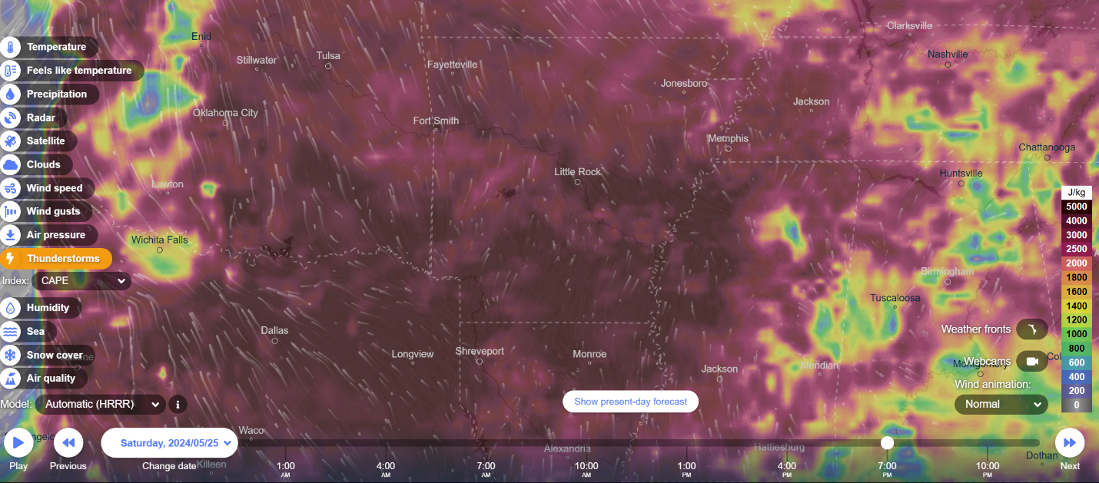

Figure 8: Ventusky GIS of Thunderstorms during DR-4788 Impact Period (1:00am 05/26/24)
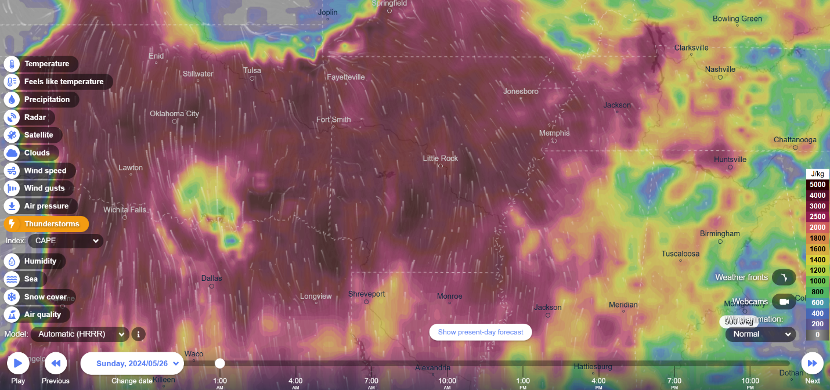
Figure 3 shows a large thunderstorm moving into Arkansas at 7:00pm on May 25th, 2024. The MID counties are highlighted in the red squares. The deepest maroon color shows a J/kg amount between 4000-5000. J/kg refers to the unit of measurement for Convective Available Potential Energy (CAPE). CAPE is a crucial measure used by meteorologists to assess the potential for thunderstorms to develop and how strong they might become. It represents the amount of energy available in the atmosphere to drive upward air movement (updrafts), which is essential for thunderstorm formation. Higher CAPE values indicate higher instability and greater potential for more powerful thunderstorms. CAPE of 3,000 to 4,000 J/Kg or higher is usually a signal of a very volatile atmosphere that could produce severe storms if other environmental parameters are in place.
Figure 4 shows the storm persisting into early May 26, 2024, and continuing to have a J/kg amount of 2500-4000. The MID counties are highlighted in the red squares. This demonstrates a severe and volatile storm system that provided the opportunity for storm-related hazards to impact the state and MID counties.

Lightning
Lightning is a channel of electrical charge that zigzags downward in 50-yard segments in a forked pattern. As it nears the ground, the charge is attracted to a channel of opposite charge reaching up, a streamer, normally through something tall, such as a tree, house, or telephone pole. When the oppositely charged leader and streamer connect, a powerful electrical current begins flowing. A bright return stroke travels about 60,000 miles per second back towards the cloud. A flash consists of one or perhaps as many as twenty return strokes. We see lightning flicker when the process rapidly repeats itself several times along the same path. It can safely be assumed any severe storm has the potential to cause a lightning strike. It can happen instantly with no warning and happen anytime throughout the storm’s passage. A strike could damage structures throughout the state and render it unusable for a period of time or cause it to catch fire and damage it beyond repair. Most lightning strikes do not hit structures or people and therefore go unreported. Residents can avoid being struck by lightning by staying indoors. Although lightning may strike a structure sheltering people, it is extremely unlikely that the strike itself will directly injure or kill a sheltered person. On average, fifty-five people are killed and hundreds are injured each year in the United States by lightning. Lightning can strike communications equipment (e.g., radio or cell towers, antennae, satellite dishes, etc.) and hamper communication and emergency response. From 1998 to 2021, NOAA has recorded sixteen significant lightning strikes in Benton County, Arkansas. These events have caused eleven injuries, one fatality, and inflicted $457,000 in property damage.

Hail
Hail is a form of precipitation that occurs when updrafts in thunderstorms carry raindrops upward into extremely cold areas of the atmosphere where they freeze into balls of ice. Hail can damage aircraft, homes, and cars, and can be deadly to livestock and people. Hailstorms will cause damage to all structures, mainly roof shingles which can lead to roof leaks and further damage to the structure interiors. All types of real estate and personal property are vulnerable to hail, such as cars, trailers, boats, and crops. Hailstorms can cause bodily injury if caught outside without protection. Hail regularly falls in Benton County each year and has been recorded up to 2.75 inches in size. Any incidents of hail can cause injury to Arkansas citizens, while anything above one inch could cause damage to structures. If windows are broken, some facilities will be rendered unusable until repaired. In the absence of proper shelter, hail can cause serious injury to an unprotected person. As long as the county of Benton’s citizens stay indoors and away from windows, they will be protected against hail injury and death. From 1956 to 2021, NOAA has recorded 359 hailstorms in Benton County, Arkansas. In most of these cases the hail reaches 1 inch in size. These hailstorms have not caused any personal injuries or deaths in the county of Benton. Hailstorms have inflicted $3,966,000 in property damage in the county of Benton.

High/Strong Wind
Damaging winds are often called “straight-line “winds to differentiate from tornado damage. Strong thunderstorm winds can come from a number of different processes. Most thunderstorm winds that cause damage at the ground are a result of outflow generated by a thunderstorm downdraft. Damaging winds are classified as those exceeding 50-60 mph. Damage from severe thunderstorm winds account for half of all severe reports in the lower 48 states and is more common than damage from tornadoes. Wind speeds can reach up to 100 mph and can produce a damage path extending for hundreds of miles. Strong winds can down trees onto power lines, damage mobile homes that are not anchored, and rip off roofing. Winds can cause death and injuries by lifting unanchored objects. As long as a structure is able to maintain its integrity during high-speed winds, it will protect people from wind injury or death. However, old, or poorly constructed facilities are not good shelters as flying debris can break windows or cause structural damage.
Strong, high, and thunderstorm winds are classified as winds which occur between 40 and 70 miles per hour lasting for one hour or greater or of 58 miles per hour for any duration. The Beaufort Scale shown below displays the ranges of wind speed and correlates them with their typical effects. At Level 7/8, citizens should remain indoors. Anywhere above Level 8 will cause damage to structures. Damage to any amount of structures can cause serious disruption to the participating governments and school districts. The scope of damage can range from a single residential home up to county-wide impacts on reinforced buildings throughout Benton County. This county occasionally receives wind events between 50 and 65 miles per hour or a Beaufort level between 9 and 10.

Figure 9: Beaufort Wind Scale Chart, NOAA
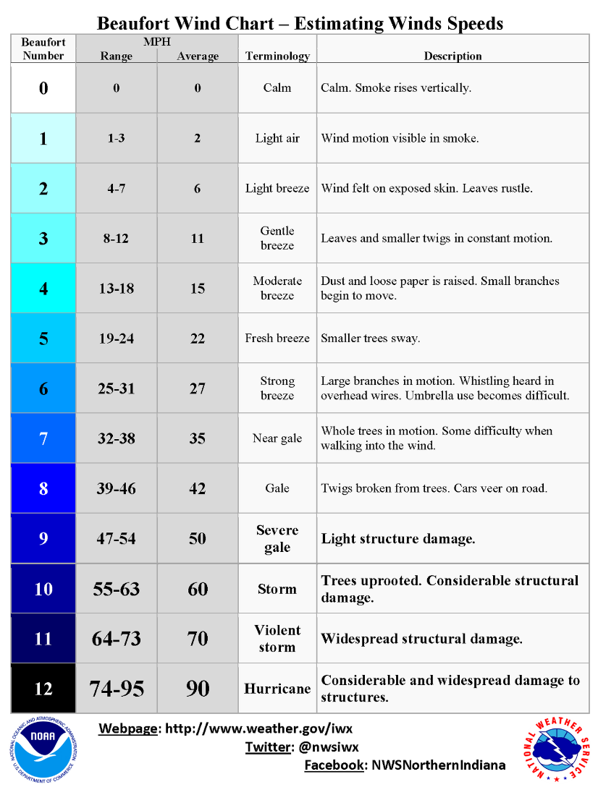
Reference: U.S. Naval Academy Sailing Safety at Sea, 2019
Between 1996 and 2021, NOAA documented 467 wind events in Benton County. The majority of these events recorded wind speeds ranging between 55 and 60 miles per hour, while some incidents reached speeds of up to 86 miles per hour. There are thirteen recorded injuries and 2 fatalities from these wind events. Wind events have caused a total of $10,354,300 in property damage throughout the county.

Drought
Drought is an abnormally dry period lasting months or years when an area has a deficiency of water and precipitation in its surface and/or underground water supply. The hydrological imbalance can be grouped into the following non-exclusive categories.

- Agricultural: When the amount of moisture in the soil no longer meets the needs of previously grown crops.
- Hydrological: When surface and subsurface water levels are significantly below their normal levels.
- Meteorological: When there is a significant departure from the normal levels of precipitation.
- Socio-Economic: When the water deficiency begins to significantly affect the population.

Droughts are regularly monitored by multiple federal agencies using a number of different indices. Typically, they are seasonal, occurring in late spring through early fall. Drought monitoring focuses on precipitation and temperature. A drought occurs when there is less precipitation than normal, and the natural water supply begins to decrease. If unusually dry weather persists and water supply problems develop, the time period is defined as a drought. Human activity such as over farming, excessive irrigation, deforestation, and poor erosion controls can exacerbate a drought’s effects. It can take weeks or months before the effects of below average precipitation on bodies of water are observed. Depending on the region, droughts can happen quicker, be noticed sooner, or have their effects naturally mitigated. The more humid and wet an area is, the quicker the effects will be realized. A naturally dry region, which typically relies more on subsurface water, will take more time to actualize its effects. Periods of drought can have significant environmental, agricultural, health, economic, and social consequences. The effects vary depending on vulnerability and regional characteristics. Droughts can also reduce water quality through a decreased ability for natural rivers and streams to dilute pollutants and increase contamination. While the whole state is vulnerable to drought, it is most disastrous in the east of the I-40 corridor of the state where the majority of agricultural businesses are located. Another good indicator of historical droughts is USDA Disaster Declarations. The following table details USDA Drought Declarations during the years of2012 through 2021 in the State of Arkansas. During that period all 75 Arkansas Counties had at least one Secretarial Drought Declaration.

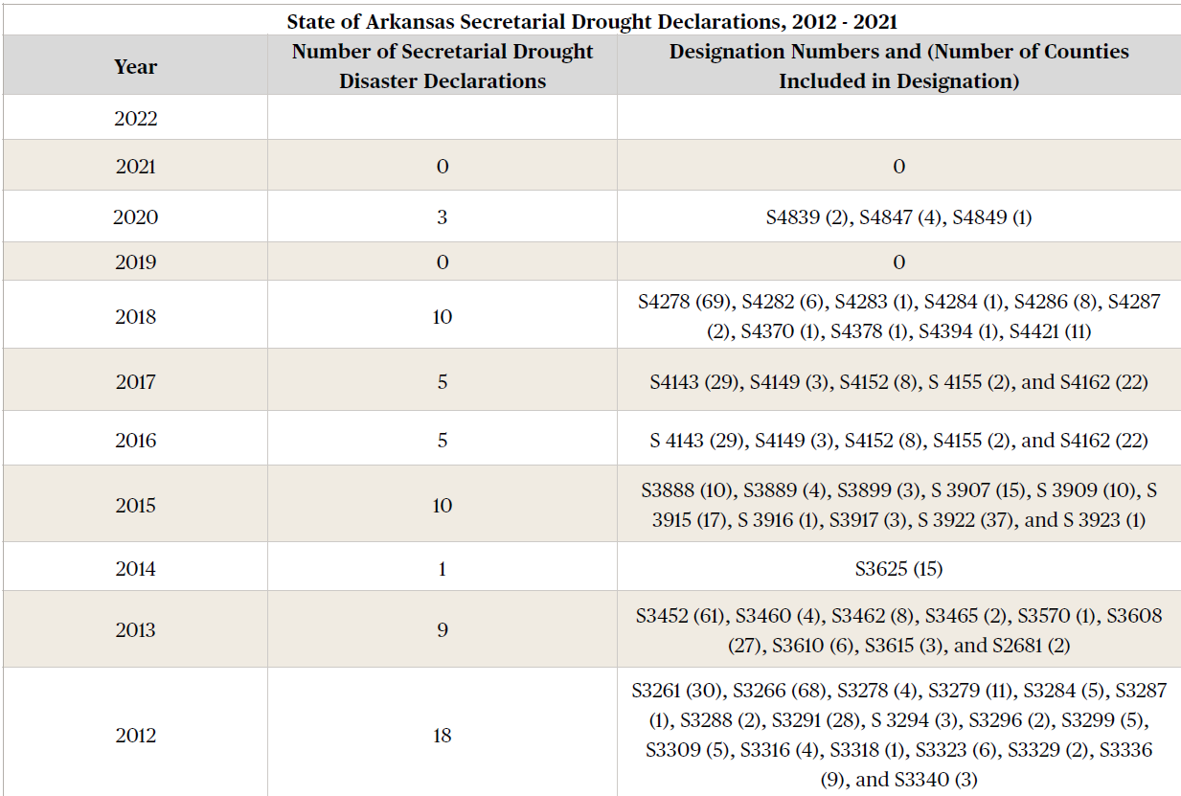
Table 32: USDA Drought Declarations 2012-2021 for the State of Arkansas

Reference: USDA Farm Service Agency, 2021, https://www.fsa.usda.gov/resources/disaster-assistance-program/disaster-designation-information

Winter Storm/Extreme Cold
Winter weather in Arkansas usually comes in the form of light snow or freezing rain. A major winter storm can last for several days and be accompanied by high winds, freezing rain or sleet, heavy snowfall, and cold temperatures. Heavy accumulations of ice, often the result of freezing rain, can bring down trees, utility poles, and communications towers. The entire state is susceptible to severe winter weather. The NWS describes the different types of events as follows:
- Blizzard: Winds of 35 mph or more with snow and blowing snow reducing visibility to less than 1/4 mile for at least three hours.
- Blowing Snow: Wind-driven snow that reduces visibility. Blowing snow may be falling snow and/or snow on the ground picked up by the wind.
- Snow Squalls: Brief, intense snow showers accompanied by strong, gusty winds. Accumulation may be significant.
- Snow Showers: Snow falling at varying intensities for brief periods of time. Some accumulation is possible.
- Freezing Rain: Rain that falls onto a surface with a temperature below freezing. This causes it to freeze to surfaces, forming a coating or glaze of ice. Most freezing-rain events are short lived and occur near sunrise between the months of December and March.
- Sleet: Rain drops that freeze into ice pellets before reaching the ground. Sleet usually bounces when hitting a surface and does not stick to objects and powerlines for days.

All government buildings and operations can be impacted due to severe winter storms. Impact normally comes in the form of delays or closure for a few hours to days. Winter-storm formation requires below freezing temperatures, moisture, and lift to raise the moist air to form the clouds and cause precipitation. Lift is commonly provided by warm air colliding with cold air along a weather front. Winter storms in Midwestern and plains states typically develop over southeast Colorado on the left side of the Rockies. These storms move east or northeast and use both the southward plunge of cold air from Canada and the northward flow of moisture from the Gulf of Mexico to produce ice, snow, and sometimes blizzard conditions. These fronts may push deep into the interior regions, sometimes as far south as Florida. When severe winter storm events do occur (the worst are typically associated with ice), they are usually wide-spread over the area and impede the movement of vehicles – limiting regular movement of traffic, causing accidents, and limiting responsiveness of emergency services. Winter storms can down power lines and seriously damage structures, thus creating potentially critical conditions for the entire area. In rural areas, homes and farms may be isolated for days, and unprotected livestock may be lost. The elderly are at increased risk for hypothermia because the skin thins with age. Accidents involving gas heaters and fires for warmth could also occur when not properly supervised, or ventilation is poor when used indoors.
Benton County will typically receive three to six inches of snow during a winter storm, but a single storm in the county of Benton has managed to accumulate up to a reported twelve inches in a single event. It has been recorded that snow from a winter storm can fall at a rate of one inch per hour. Additionally, Benton County and its participating jurisdictions have seen up to one inch of accumulated ice, typically receiving ½ inch of accumulation from an ice storm. According to National Climatic Data Center (NCDC) and National Weather Service Data, typical snow accumulations in Pulaski County during heavy snow and winter storm events ranges from two inches to eight inches. Typical ice storm accumulations range from one inch to 1 ½ of inches.

Flooding
While the hazards of flash flooding and riverine flooding are often designated separately, they will be briefly discussed together because often people will just refer to “flooding”, especially when referring to the damage they cause, and no distinction is made whether the flood event was riverine or flash. In fact, FEMA disaster declarations usually do not designate in the title of a disaster whether flooding was flash or riverine. In the following subsections, riverine and flash flooding will be discussed separately.

Flash Flooding
A flash flood is an event that occurs with little or no warning, where water levels rise at an extremely fast rate. Flash flooding results from intense rainfall over a brief period, sometimes combined with rapid snowmelt, ice jam release, frozen ground, saturated soil, or impermeable surfaces. Most flash flooding is caused by slow-moving thunderstorms or thunderstorms repeatedly moving over the same area. Even with information on soil saturation and predicted rainfall, flash floods can still catch people by surprise. Flash flooding is an extremely dangerous form of flooding that can reach full peak in only a few minutes and allows little or no time for protective measures to be taken by those in its path. Flash flood water moves at very fast speeds and can move boulders, tear out trees, scour channels, destroy buildings, and obliterate bridges. Flash flooding often results in higher loss of life, both human and animal, than slower developing river and stream flooding. A flash flood event can impact areas far from a tributary or body of water. Nearly half of all flash flood fatalities are automobile related. Motorists often try to traverse water-covered roads and bridges and are swept away by the current. Depending on the severity, overall disruption may occur for just a few hours, causing minor inconveniences, or up to months, causing major environmental and economic impacts in the county and State.

Riverine Flooding
A riverine flood is a temporary condition of partial or complete inundation of normally dry land areas from the overflow of stream banks. Flooding occurs when the flow of water is greater than the normal carrying capacity of the stream channel. Floodwater can be extremely dangerous; the force of 6 inches of swiftly moving water can knock people off their feet and two feet of water can float a car. Floods can be slow- or fast-rising but generally develop over a period of days. Flooding is a natural and expected phenomenon that occurs annually, usually restricted to specific streams, rivers, or watershed areas.
Riverine flooding does not have as high of a risk to humans as flash flooding does, mostly because of the slow onset of river flooding. People in a flood zone, downstream from a dam or levee, or in low-lying areas are especially vulnerable in any type of flood event. In addition, people located in areas with narrow stream channels, saturated soil, or on land with large amounts of impermeable surfaces are likely to be impacted in the event of significant rainfall.

Tornado
A tornado is a violent windstorm characterized by a twisting, funnel-shaped cloud. Tornadoes are most often generated by thunderstorm activity but sometimes result from hurricanes and other tropical storms. Tornadoes occur when cool, dry air intersects and overrides a layer of warm, moist air, forcing the warm air to rise rapidly. Tornado wind speeds normally range from 65 mph to more than 200 mph, but can reach more than 300 mph. The maximum winds in tornadoes are often confined to extremely small areas and vary tremendously over short distances, even within the funnel itself. These storms typically travel around 10 to 20 mph but can move at more than sixty mph. Damage paths can vary from as narrow as 1 mile to as wide as fifty miles. Tornadoes can occur at any time of the year and at any time of the day. Tornadoes are measured by their intensity in terms of wind speed and their area using the Enhanced Fujita (EF) Scale. The scale ranges from EF0, with minor damages from winds ranging 65–85 mph, to EF5, with severe damages from winds more than 200 mph.
Table 33: The Enhanced Fujita Scale (EF Scale)
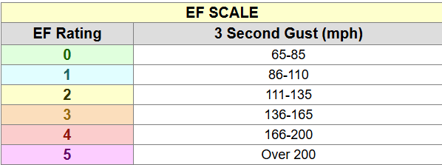
Reference: NOAA National Weather Service, n.d.
The Enhanced Fujita Scale or EF Scale, which became operational on February 1, 2007, is used to assign a tornado a 'rating' based on estimated wind speeds and related damage.
Tornadoes have occurred throughout Arkansas at any time of the year, especially when there is a warm spell and then a cold front moves in. Warmer winter and fall months have resulted in expanded tornado season in Arkansas. Trends in the tornado activity show that the “Tornado Alley” region — the area from central Texas through Oklahoma and Kansas, so named because of the number of tornadoes there — is shifting eastward. The shift is attributed to increasing hazards, the warming of the Gulf of Mexico’s waters and a dip in the cold jet stream pattern. Arkansas, scientists say, is nearly in the bull’s eye of a new tornado-prone area that is referred to as “Dixie Alley.” The region, which has seen a vast increase in tornadoes over the past several years, also encompasses Mississippi, Alabama and western Tennessee.
All populations in Arkansas are at risk of experiencing a tornado. Populations that are houseless or living in mobile homes can be more at risk of being impacted if a tornado occurs in an area. A few governments building have reinforced structures that may reduce the likelihood of damage however this is limited statewide. The built environment in the entire state can be impacted by a tornado where they occur. Power lines and above ground utilities are most at risk where is concerns the built environment. The economic impact could be limited to a community level or felt statewide. Due to vast number of hills and trees, tornadoes are less visible in Arkansas making it part of the “Tornado Fatality Alley." In Arkansas, there is a higher likelihood of killer tornadoes and severe storms due to multiple factors: (1) the highest percentage of manufactured/mobile homes compared with any other region east of the Continental Divide, and (2) a close proximity to the Gulf of Mexico and a feed of warmth/moisture to sustain storms long after sunset.
Table 34: State of Arkansas Tornado Storm Data Summary 2018 - 05/01/2023
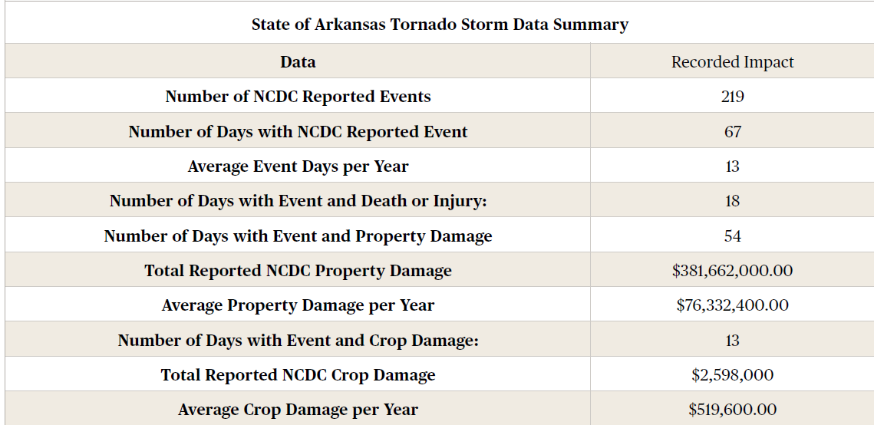
Reference: 2023 State of Arkansas Hazard Mitigation Plan

Indispensable Services
Indispensable services are those that enable the continuous operation of critical business and government functions and/or are critical to human health, safety, and economic security. These services are largely operated out of critical facilities. A critical facility provides services and functions essential to a community, especially during and after a disaster. Examples of indispensable service-providing facilities requiring special consideration include:
- Police stations, fire stations, critical vehicle and equipment storage facilities, and emergency operations centers needed for disaster response activities before, during, and after a disaster.
- Medical facilities, including hospitals, nursing homes, blood banks, and health care facilities (including those storing vital medical records) likely to have occupants who may not be sufficiently mobile to avoid injury or death during a disaster.
- Schools and day care centers, especially if designated as shelters or evacuation centers.
- Power generating stations and other public and private utility facilities vital to maintaining or restoring normal services to flooded areas before, during, and after a flood.
- Drinking water and wastewater treatment plants.
- Structures or facilities that produce, use, or store highly volatile, flammable, explosive, toxic, and/or water-reactive material.

State facilities are the facilities that are owned (or leased/operated) by the State of Arkansas. Some facilities are critical or valuable in ways that cannot necessarily be expressed in dollars. Utilities and medical facilities are such facilities. Determining what is “critical” or not is sometimes a matter of opinion. While utilities and medical facilities are generally agreed upon as critical, some other facilities are key to operations, necessary to maintaining emergency services, and essential for providing necessary basics. Facilities that help keep roads open and clear throughout the year, whether the sun is shining, or blizzards abound, is an example of such a key facility. Though often overlooked, but certainly essential for keeping roads open, is the facility where salt or brine is stored so that it can be used to treat roads in severe winter weather and keep them open.

Vulnerability of Critical Facilities by Hazard
The following vulnerability assessment will focus on vulnerabilities in critical facilities located within the most impacted and distressed (MID) counties, as identified by the Allocation Announcement Notice published in the Federal Register / Vol. 90, No. 10 / Thursday, January 16, 2025. When discussing impacted critical facilities, this section will highlight the available data in the Pulaski and Benton counties hazard mitigation plans, as well as the 2023 State of Arkansas Hazard Mitigation Plan. There is limited data available to investigate the vulnerability of critical facilities in Cross County, Arkansas (excluding the City of Little Rock).

Severe Storm Impacts on Facilities
Hail can be costly by damaging rooftops, outdoor equipment, and windows. Lightning can strike anything with the potential to significantly damage electrical infrastructure or ignite a fire. Wind events create flying debris which can damage infrastructure and buildings. Strong enough wind can cause structural damage to older, less well constructed buildings even toppling or leveling them. NOAA records catalog that the county of Benton regularly reports severe storm damage to roofs and power lines while also uprooting and downing trees. Any structures not properly constructed or anchored could be damaged. Significant changes to national building codes were implemented in 1999, and structures built before then are considered to be more vulnerable than those constructed afterwards. The average hailstorm in the county of Benton costs $11,047 in property damage. A single hail incident can result in up to $2,500,000 in damage costs. The average lightning strike in the county of Benton inflicts $28,562 in property damage. Lightning strikes can cause significant damage to buildings, critical facilities, and infrastructure, largely by igniting a fire (and even wildfire). The range of a single lightning strike incident can result in up to $200,000 in damage costs. Benton County and its participating jurisdictions’ municipal structures are valued at $20,052,529,000 and their school district structures are valued at $1,785,546,297, for a total value of $21,838,075,297. Since severe storms threaten the entire county of Benton equally, all municipal and school district structures are considered exposed and vulnerable, except for the identified safe rooms at the Decatur and Pea Ridge School Districts bringing the total exposed value of municipal and school district structures to $21,835,413,893. In Pulaski County, a total of 626 state owned structures valued at $854,340,146 and 198 critical facilities valued at $848,605,823 are vulnerable to severe storms.

Drought Impacts on Facilities
Drought’s primary impact is on agriculture and livestock and thus can have significant effects on a jurisdiction’s agricultural and tourist economies. If the precipitation level is below normal, farmers and ranchers will struggle to grow their crops and feed their livestock. If rivers, streams, and lakes dry up, tourists will be less likely to enjoy a jurisdiction’s amenity resources. The county of Benton hosts 1,936 farms across 243,753 acres of land. The USDA estimates that the total value of products from these farms is $593,371,000 per year. All of them are considered vulnerable to droughts.

Winter Storm/Extreme Cold Impacts on Facilities
Heavy accumulations of ice and snow can cause structural damage, either from excessive weight or falling ice-laden trees and branches. Homes, businesses, and nonresidential structures, particularly poultry houses in Arkansas, are highly vulnerable. Rebuilding delays result in additional agricultural revenue losses. Ice storms and heavy snow frequently damage trees, electrical wires, telephone poles, and communication towers, leading to power and communications outages that may last several days. The cost of snow removal, infrastructure repairs, and business disruptions can be substantial. Motorists face increased hazards due to icy roads, particularly in Pulaski County, where drivers are generally unaccustomed to such conditions, often resulting in traffic accidents and fatalities. The state’s limited snow removal and road treatment resources further compound travel difficulties, business closures, and school disruptions. Winter storms, often accompanied by strong winds, can create blizzard conditions with severe drifting and extreme wind chills, further damaging trees, utility poles, and power lines. While power grid failures and infrastructure vulnerabilities pose economic challenges, agriculture remains the most impacted sector due to widespread exposure. Structural vulnerability in Benton County is consistent across jurisdictions. Heavy snow accumulation can cause roof collapses in older or poorly constructed buildings, while ice storms generally result in superficial exterior damage. Prolonged freezing temperatures can lead to significant damage, particularly frozen and burst pipes in inadequately insulated facilities. Since winter storms affect the entire county equally, all municipal and school district structures are considered exposed and vulnerable. The National Weather Service (NWS) and NOAA have recorded $30,250,000 in property damage from winter storms in Benton County, with costs ranging up to $30,000,000 per event and an average per-storm damage estimate of $945,312.

Flooding Impact on Facilities
Flash flooding does not often cause widespread damage to property or infrastructure and is limited to its ability to impact systems. Even in the case of a damaged roadway, the problem is often limited to secondary roadways. Recreational vehicles and mobile homes located in low-lying areas also can be swept away by water. Buildings, infrastructure, and land can be eroded, extensively damaged, or destroyed in a flood event. Disruption or complete shutdown of essential facilities and services, such as major travel routes, water distribution, and wastewater treatment facilities, often occur during severe flood events. However, catastrophic riverine flooding can cause significant damage to a community’s systems. Extensive riverine flooding can significantly impact local governments’ ability to provide basic goods and services to their communities either by losing essential facilities or by blocked infrastructure. This can take the form of lost law enforcement, fire prevention, medical, or water treatment facilities. Considerable damage to residential and/or commercial structures can irrevocably damage a community and its economy. If a chemical facility is significantly impacted, it is possible the chemicals stored at the facilities can wash away with the flood waters and have detrimental effects on the local environment. Flooding can cause minimal or complete damage to any of these types of facilities, taking them offline for days to years depending on the resources available and remediation costs after an event. The county of Benton has incurred a total of $0 in property damage from riverine floods and $7,740,000 in property damage from flash floods. Since flash flooding threatens the entire county of Benton, all structures are considered exposed and vulnerable. A GIS analysis of FEMA’s identified Special Flood Hazard Areas (SFHAs) demonstrates $2,390,750,000 worth of the county of Benton’s municipal structural inventory is exposed to riverine flooding. None of the school districts structures are vulnerable to riverine flooding, while all are vulnerable to flash flooding. The Bentonville and Rogers School Districts have some buildings that are dangerously close to, but not within identified floodplains. Of the county of Benton’s 214 critical facilities, fifteen are located within identified floodplains. As previously discussed, both riverine and flash flooding has closed down numerous transportation routes within the county of Benton causing temporary limitations of the county of Benton’s residents and business to go about their daily lives.

Dam Failures
According to the Association of State Dam Safety Officials, the term dam is defined in the rules as “any barrier, including one for flood detention, designed to impound liquid volumes.” A dam failure is the collapse, breach, or other failure resulting in downstream flooding. A dam impounds water in the upstream area, referred to as the reservoir. The amount of water impounded is measured in acre-ft. An acre-foot is the volume of water that covers an acre of land to a depth of one foot. As a function of upstream topography, even a very small dam may impound or detain many acre-ft. of water. Two factors influence the potential severity of a full or partial dam failure: the amount of water impounded, and the density, type, and value of development and infrastructure located downstream. According to the Natural Resource Division, Dam Safety Branch of the Arkansas Department of Agriculture, there are a total of seventy-five regulated dams throughout Pulaski County. Of these dams, nineteen are classified as high hazard dams, thirty are classified as significant hazard dams and 26 are classified as low hazard dams. All of the dams were constructed between 1913 and 1970. Regular inspection and maintenance will circumvent future events. Based upon having no historic events, the probability is less than 1% in any given year that a future dam failure will occur. Populations within a dam failure inundation area are at extreme risk. Depending on the speed of the water’s arrival, a community’s population may not have time to evacuate. Additionally, evacuation routes can be blocked by dam waters. Depending on the elevation of the water, a community’s population may not have any available shelter to avoid the waters. Dam failures directly threaten 877 housing units and 1,894 people throughout Benton County. A loss of water reserves as a result of a dam failure is not likely to affect the county of Benton’s agricultural production due to the overabundance of storage tanks and water reservoirs throughout the area. Transportation infrastructure would be impacted by a dam failure, but primary and secondary roads can often be circumvented.

Tornado/High Wind Impact on Facilities
Building to modern wind standards and state codes provides significant protection from tornado and high wind events. However, a community in the direct path of a violent, high scale tornado can do little to prevent significant property damage. Designing buildings to protect against extreme wind speeds, such as those associated with an EF4 or EF5 is extremely challenging and cost prohibitive. Anything less than a FEMA Code 361 compliant structure is susceptible to significant damage or complete destruction. Benton County and its participating jurisdictions’ municipal and public-school district structures are valued at a total of $21,838,075,297 ($20,052,529,000 municipal, $1,785,546,297 school district). Since tornadoes threaten the entire county of Benton equally, all municipal and school district structures are considered exposed and vulnerable except for the identified safe rooms at the Decatur and Pea Ridge School Districts bringing the total down to $21,835,413,893. Benton County and its participating municipal jurisdictions have a total population of 284,333 in 90,084 housing units, all of which are vulnerable and at risk to tornadoes. A small magnitude tornado will not significantly damage a community and its systems, but a larger magnitude tornado can impact a community for weeks, months, years and can even destroy a city completely. Significant damage to any portion of the county of Benton would hinder the community’s economy and increase its social vulnerability. The average wind event in the county of Benton costs $22,172, while a single wind incident can result in up to $3,500,000.

Conclusion
As this Mitigation Needs Assessment makes clear, there are at least five natural hazards that pose a considerable risk to the State of Arkansas and its MID counties. By characterizing these hazards in terms of their frequency and the impacted area’s vulnerability, ADFA and its subrecipients can use this needs assessment to identify current and future hazards in their communities and target CDBG-DR funds toward cost-effective solutions to mitigate them over the long term. In addition, this assessment will inform all CDBG-DR programs and activities undertaken as part of this allocation such that, at a minimum, they do not exacerbate hazards but rather serve to lessen their impacts. The mitigation set-aside funds in the Homebuyers Assistance Program, and the Multi-Family New Construction Program will address these needs.

5
Connection of proposed programs and projects to unmet needs and mitigation needs

Connection of proposed programs and projects to unmet needs and mitigation needs.

CDBG-DR Program Allocation and Funding Thresholds
ADFA has structured its CDBG-DR programs to specifically address the most significant and impactful unmet and mitigation needs arising from the 2023 & 2024 disaster events. ADFA plans to have five CDBG-DR programs, a general planning program, a down payment assistance program, a multifamily new construction program and a non-federal FEMA match infrastructure program. These programs are based on detailed data analyses, including FEMA IA verified losses, housing damage assessments, and infrastructure vulnerability profiles, especially in the HUD-designated MID counties of Benton, Cross, and Pulaski. Table 35 below outlines the amount of CDBG-DR funding allocated to each program.
The unmet needs analysis showed the majority of impacted homeowners experienced minor damage that was largely funded with FEMA and other sources. Due to that fact, it was established that the greater need was for new, more resilient housing. The disaster has also exacerbated the lack of affordable rental and owner-occupied housing in Northwestern Arkansas. The area is one of the fastest growing metropolitan areas in the country and home to several Fortune 500 companies. This has led to a population growth in the area that has outpaced housing and created a need for more affordable and safe housing according to the “Our Housing Future: A Call to Action for Northwestern Arkansas” report. The report further states that “currently the region needs to make available 9,300 affordable rental units for workers making less than 80% of the area median income to satisfy current demand.” There is a preponderance of detached single-family homes, but not the more affordable attached single-family homes or manufactured housing. There is also a lack of medium-scale multifamily buildings. This same area was also hit with devastating tornados in May 2024 and Benton County has been established as a HUD MID. A high number of both owner-occupied housing and rental housing was damaged by the disasters. In July 2025, ADFA distributed an unmet needs and recovery priorities survey via email to stakeholders and on its disaster recovery website. The results, detailed in Appendix 8.2 of this Action Plan, reflect feedback from 85 respondents. A majority identified housing and shelter, along with public facilities and infrastructure, as the most urgent recovery needs. Respondents indicated that programs focused on new housing construction and infrastructure repairs would be most beneficial to their communities. The top priorities cited were Non-Federal Match to FEMA and housing recovery assistance for low- to moderate-income individuals. The results of this survey are in line with the programming that ADFA plans with its CDBG-DR allocation.
Benton County has seen a dramatic increase in median home sale prices, roughly doubling since 2019. This indicates a high demand for housing and significant financial losses due to disaster impacts. Investing in new housing construction in the MID counties will ensure that residents have access to safe and resilient housing options. This approach supports long-term recovery and helps prevent future displacement. As detailed in Section 3.1.1, the unmet need for owner-occupied housing is $122.6 million, and for rental housing is $31.5 million, totaling over $154 million in remaining unmet need for housing. This figure is based on FEMA data on housing impacts and housing need calculated based on the current housing metrics of the impacted areas. The additional funding will make the housing market more resilient to future housing demand. Rental new housing construction is also an extremely effective way to support disaster impacted tenants that may not have control over whether their landlord makes necessary repairs to original housing. ADFA is an expert in new housing construction and has existing policies and programs that can easily be adapted to meet CDBG-DR requirements. They are familiar with the housing markets in the HUD MID areas. This will allow the CDBG-DR funding to be allocated more quickly. Because of these factors, ADFA will utilize the largest portion of their CDBG-DR funding on the creation of affordable housing and the infrastructure to support it. Their programs will be designed to respond to the need for different types of housing and with a good mix of new owner-occupied and rental housing.
ADFA recognizes that housing recovery needs will be addressed through qualifying newly constructed housing that is already available within the market. The State has therefore replaced the Single-Family New Construction program with a Down Payment Assistance Program. The revised program will assist eligible households through down payment assistance and closing cost assistance to purchase qualifying homes available within the existing housing market. By providing assistance directly to homebuyers rather than funding developer-led construction activities, ADFA expects to serve more households, accelerate housing recovery, and maximize the impact of available CDBG-DR funds. Newly constructed housing is more resilient due to the adherence to the updated residential building codes that address resilience measures that align with national standards, therefore safer housing is being provided.

ADFA also plans to pursue an infrastructure program to fund the FEMA Non-Federal Match gap for communities that lack resources to fund themselves. A priority will be placed on providing the FEMA non-federal match to low-to moderate income communities. These communities are already burdened with immediate recovery needs and do not have the resources or funding to cover the Non-Federal Match to fully restore and improve existing infrastructure. As shown in Section 3.2, the MID counties account for 83% of the total FEMA Public Assistance non-federal match need, with Pulaski County alone requiring over $10.5 million. This program will prioritize infrastructure projects that restore indispensable services (Section 4.6), such as water treatment, emergency response, and power generation, ensuring that communities are not only rebuilt but made more resilient to future disasters. Leveraging CDBG-DR to fund infrastructure recovery benefits a large number of residents and ensures the community is left more resilient in the face of future disasters.
Investing CDBG-DR funds in housing and infrastructure is essential to address the unmet needs identified. This investment will not only help the affected residents recover but also accommodate the growing population in Northwest Arkansas. By focusing on improving infrastructure and expanding housing options, ADFA can ensure that the communities are better prepared for future challenges and can thrive in the long term.

Table 35: CDBG-DR Program Allocation and Funding Thresholds
Eligible Cost Category | CDBG-DR Allocation Amount | % of CDBG-DR Allocation | Estimated $ to CDBG-DR Mitigation Set-aside | Estimated % to HUD MID Areas | Estimated % to LMI
Administration | $2,952,400 | 5% | N/A | N/A | N/A
Planning | $1,000,000 | 1% | $137,300 | 100% | N/A
Housing  Down Payment Assistance & Multi-Family New Construction | $49,000,000 | 83% | $7,564,700 | 100% | 60%
Infrastructure  Non-Federal FEMA Match | $6,095,600 | 11% | N/A | 100% | 10%
Total | $59,048,000 | 100% | $7,702,000 | 100% | 70%

Hazard Mitigation Measures
All infrastructure and new construction housing projects funded through ADFA CDBG-DR allocation will incorporate hazard mitigation measures and strategies to reduce future risk.
Mitigation strategies will be tailored to the hazard profiles identified in Section 4.5. For example:
- In flood-prone areas, homes will be elevated and sited outside of 100- and 500-year floodplains.
- In tornado-prone zones, construction will include wind-rated windows, reinforced roofing, and safe rooms.
- In areas vulnerable to winter storms, materials will be selected for freeze resistance and structural durability.
In addition, the CDBG-DR projects will be designed and constructed to withstand chronic stress and extreme weather events to the extent practicable. ADFA will allocate additional funding in its housing programs to allow for extra measures to be taken to reduce future risks. ADFA will ensure that funded projects utilize the best practices in risk reduction.

Minimizing Displacement
ADFA is committed to minimizing the displacement of people and entities resulting from CDBG-DR-funded projects. New construction of housing and Infrastructure inherently carry a low risk of residential displacement; however, ADFA will take all reasonable steps to avoid or minimize displacement and, where displacement is unavoidable, to provide appropriate relocation assistance in accordance with the Uniform Relocation Assistance and Real Property Acquisition Policies Act of 1970 (URA) and Section 104(d) of the Housing and Community Development Act. This consideration will include the accessibility needs of displaced persons.

ADFA will also ensure that the new housing construction and infrastructure improvements are designed to meet the accessibility needs of individuals, consistent with the Americans with Disabilities Act (ADA), Section 504 of the Rehabilitation Act of 1973, and other applicable civil rights laws.

6
Allocation, Award Caps, and Program Description

Allocation, Award Caps, and Program Description

General Exception Criteria
Maximum awards amounts, where applicable, are identified by program in the sections below. At the time of submission, maximum award amounts were established for all required programs and ADFA does not anticipate changes. However, ADFA may provide exceptions to award maximums on a case-by-case basis and will include procedures within program guidelines on how ADFA or its subrecipients will analyze the circumstances under which an exception is needed and the amount of assistance as necessary and reasonable.

Grantee Administration Activity Overview
Table 36: Grantee Administration Activity Allocation Amount and Percentage
CDBG-DR Allocation Amount | % of CDBG-DR Allocation
$2,952,400 | 5%

Five percent of the overall grant will be used for administration of the grant, including compliance monitoring, performance tracking, grant reporting, and general administrative activities.

Planning Overview
Table 37: Planning Allocation Amount and Percentage
CDBG-DR Allocation Amount | % of CDBG-DR Allocation | $ of CDBG-DR Mitigation Set-Aside
$1,000,000 | 1% | $137,300

Eligible Activities:
Planning; HCDA Section 105(a)12; applicable waivers identified in the Allocation Announcement Notice (90 FR 4759) and Universal Notice (90 FR 1754).

National Objective:
Planning activities are presumed to meet a national objective under the requirements at 24 CFR 570.208(d)(4).

Lead Agency and Distribution Model:
ADFA will serve as the lead agency for the allocation of funds to eligible subrecipients.

Lead Agency for Environmental Reviews:
The Local Planning Program must be in compliance with the National Environmental Policy Act (NEPA), and other related federal and state environmental laws. Planning is Categorically Excluded Not Subject to (CENST) Section 58.5 pursuant to 24 CFR Part 58.34(a)18 and 58.35(b)19. ADFA will serve as the Responsible Entity (RE), as defined in 24 CFR 58.4. As the RE, ADFA assumes the authority for decision-making and completion of the environmental review and completed the CENST at the CDBG-DR program level for Planning Activities.

Program Description:
The Local Planning Program will support disaster-impacted MID areas to better prepare for future disasters. Funding for the Program will be allocated to subrecipients. This program will provide critical planning funding to support communities to update local disaster response plans, hazard mitigation plans, evacuation plans, emergency communication plans, and other recovery plans. By strengthening disaster and mitigation planning at the local level, the program empowers these communities to make informed decisions, improve preparedness, and better withstand future disasters.

Eligible Geographic Areas:
CDBG-DR funding will be provided to the HUD-identified MID areas: Benton County; Cross County; and Pulaski County (excluding the City of Little Rock).

Maximum Amount of Assistance:
There is a maximum award amount of $50,000 per application.

Mitigation Measure
The objective of this program is to provide funding to subrecipients in disaster-impacted MIDs areas to strengthen disaster and mitigation planning at the local level. Through targeted planning support, communities will be able to integrate lessons learned from DR-4698 and DR-4788, identify specific local vulnerabilities, and prioritize actions that reduce the risk of future storms and flooding. By investing in local planning capacity, this Program establishes a foundation for long-term resilience, empowering communities to make informed decisions, improve coordination, and enhance their ability to withstand future disasters.

Funding Criteria
Applicants potentially eligible for funding will be units of general local government. Applicants may partner with local universities or non-profit partners as co-applicants to the Program. Eligible applicants will be able to submit applications during the application window, as identified in a published NOFA. The Local Planning Program is a non-competitive, first-come, first-served program.
The evaluation criteria for applications and funding awards will include, but are not limited to:
- Description of the Planning Activity
- Planning Location
  - Confirming benefit to HUD-identified MID areas)
- Tie-back and Mitigation
- Eligibility
  - Proposed planning activity must be consistent with the categories established in 24 CFR 570.205 and the plan lays the groundwork for long-term resilience and prioritizing actions that reduce future vulnerabilities
- Subrecipient Capacity
- Budget
- Cost Effectiveness
- Timeline
  - All projects funded under the Program must be completed within two (2) years of grant award
Applicants will be eligible for funding provided eligibility criteria are met and funding is available.

Reducing Impediments for Assistance
To encourage application submission and reduce impediments for potentially eligible applicants, ADFA will host an application workshop to provide an overview of the Program goals, required documentation, and to offer a forum for questions. ADFA will provide technical assistance to all interested and selected applicants throughout the project period.

Housing Overview
ADFA is proposing two housing programs aimed at assisting Arkansas residents in replacing homes that were damaged or destroyed, with new housing stock that is resilient to hazards within the affected communities.
While APA 1 removes the standalone Infrastructure in Support of Housing activity, infrastructure improvements that are directly necessary to support housing projects remain eligible when included as part of the housing activity. Infrastructure costs must be clearly tied to the development of CDBG‑DR‑assisted multi-family housing units and will be evaluated within the housing programs rather than as a separate infrastructure program.
Grantee Housing Programs
Table 38: Housing Program Allocation Amounts and Percentages per Cost Category

Eligible Cost Category | CDBG-DR Allocation Amount | % of CDBG-DR Allocation
Down Payment Assistance | $20,000,000 | 34%
Multi-Family New Construction | $29,000,000 | 49%
Housing Program Total: | $49,000,000 | 83%

Down Payment Assistance

Table 39: Down Payment Assistance Allocation Amount and Percentage
CDBG-DR Allocation Amount | % of CDBG-DR Allocation | $ of CDBG-DR Mitigation Set-Aside | % Estimated to LMI
$20,000,000 | 34% | $3,087,455 | 70%

Eligible Activities:
Homeownership assistance; HCDA Section 105(a)24; applicable waivers identified in the Allocation Announcement Notice (90 FR 4759) and Universal Notice (90 FR 1754), as amended.

National Objective:
Low to Moderate Income Housing (LMH) benefit and Urgent Need

Lead Agency and Distribution Model:
While ADFA will serve as the lead agency for this program, there will be a vendor implementing the program and will ensure all applicant files are compliant prior to grant execution or award denial. Funds will be provided to qualified applicants on a first come, first-serve basis through an application cycle. Homebuyers will sign a grant agreement with the ADFA prior to receiving assistance from the program.

Lead Agency for Environmental Reviews:
Projects funded through HUD and administered by ADFA must comply with environmental review requirements under 24 CFR Part 58. ADFA will serve as the Responsible Entity (RE), as defined in 24 CFR 58.4. As the RE, ADFA assumes the authority for decision-making and completion of the environmental review. ADFA will submit their environmental certification and Request for Release of Funds (RROF) directly to HUD.

Program Description:
The Homebuyers Assistance Program (HAP) will facilitate affordable housing through homebuyer assistance for qualifying existing or new construction housing stock in that meet current building and mitigation standards in the disaster-impacted MID areas. HAP will provide direct assistance to eligible residents to enhance homeownership opportunities and will be available to eligible homebuyer households earning up to 120% of the AMI living in the MID counties. HAP will prioritize serving households who are under 80% of the AMI and disaster-impacted residents before opening up the program to households earning between 80.1% and 120% AMI. Prospective homebuyers will be required to complete a housing counseling course.
Eligible households may receive the lesser of $50,000 or 20% of the price to purchase a newly constructed or manufactured home located in the three MID counties. Final award amounts will be based on the needs of the households after qualifying for a non-predatory affordable mortgage through either a traditional market lender or a non-traditional lender. Assistance may be used for down payment assistance and/or eligible closing costs to provide an affordable mortgage amount. Eligibility, underwriting, and home standards will be further detailed in the program policies.
Communities continue to face significant housing recovery needs following the disaster events. ADFA recognizes that these needs may be addressed through expansive homebuyer eligibility for qualifying newly constructed housing that is already available within the market.
Eligible Geographic Areas:
CDBG-DR funding will be provided to the HUD-identified MID areas: Benton County; Cross County; and Pulaski County (excluding the City of Little Rock).

Maximum Amount of Assistance:
This program will provide maximum awards of up to the lesser of $50,000 or 20% of the home purchase, including closing costs,

Maximum Income of Beneficiary:
LMI Households will be prioritized with maximum income capped at 120% AMI. Specific income limits will be published in the program policies and procedures and will be based on the current HUD LMI income limits.

Mitigation Measures:
The objective of this program is to encourage homeownership in the MIDs of safe, sanitary, and durable housing that is specifically designed to withstand future disasters. To incentivize this, eligible properties for homeownership under HAP must have been constructed under the Arkansas 2021 building code. Homes constructed under Arkansas's 2021 building code are more resilient to future disasters due to updated wind design standards, stronger roof and structural connection requirements, and enhanced flood-resistant construction provisions. These updates help reduce damage from high winds, severe storms, and flooding, improving a home's ability to withstand future hazard events and lowering long-term recovery costs
In addition, HAP provides homeownership assistance for first-time homebuyers to create opportunities for long-term, stable, affordable housing for those with a higher risk of housing instability.
A first-time homebuyer may be defined as:
A homemaker or single parent who has previously owned a marital home and is now owned by the former spouse
• An individual who has only owned a property that was not permanently affixed, i.e. mobile home, to a permanent foundation
• An individual who has only owned a property that was not in compliance with state, local, or model building codes, and which cannot be brought into compliance for less than the cost of constructing a new permanent residence
• An individual who has had no ownership in a residence during the 3 years ending on the date of the purchase of the property
• An individual replacing a home that was lost during the 2023 or 2024 storm
Households will be required to have an pre-qualified for a mortgage to be eligible for HAP, which helps ensure that the household’s investment is protected and that they have enough money left over each month for maintenance, repairs, and savings so that they would have the resources available for recovery in the face of a future disaster.
Additionally, homes purchased will undergo inspection prior to purchase to confirm HAP eligibility as described in the program guidelines.

Funding Criteria:
ADFA has established funding criteria to effectively address the unmet needs resulting from the severe storms and tornadoes that impacted each affected community,
The criteria for home purchase awards under DPA will include, but are not limited to:
- Requirement that homes have been constructed under the 2021 Arkansas residential building code.
- Confirmation that the housing unit is outside of the 100- and 500-year regulatory floodplains.
- The home must be located within a HUD Identified Most Impacted and Distressed (MID) area.

Reducing Impediments for Assistance:
ADFA will collaborate with lenders and realtors located in the three MIDs to create outreach and marketing strategies aimed at encouraging individuals impacted by the disaster to apply for the homebuyer assistance offered through this program.

Multi-Family New Construction
Table 40: Multi-Family New Construction
CDBG-DR Allocation Amount | % of CDBG-DR Allocation | $ of CDBG-DR Mitigation Set-Aside | % Estimated to LMI
$29,000,000 | 49% | $4,477,245 | 100%

Eligible Activities:
New construction, acquisition, clearance; HCDA Section 105(a)1, 2, 4, 5, 8, 11, 14, 15, and 24; applicable waivers identified in the Allocation Announcement Notice (90 FR 4759) and Universal Notice (90 FR 1754).

National Objective:
Low- and- moderate income housing (LMH); 51% of the units will be occupied by LMI households.

Lead Agency and Distribution Model
ADFA will serve as the lead agency for this program distributing funding directly to developers through a competitive process.

Lead Agency for Environmental Reviews
Projects funded through HUD and administered by ADFA must comply with environmental review requirements under 24 CFR Part 58. ADFA will serve as the Responsible Entity (RE), as defined in 24 CFR 58.4. As the RE, ADFA assumes the authority for decision-making and completion of the environmental review. ADFA will submit their environmental certification and Request for Release of Funds (RROF) directly to HUD.

Program Description
The Multi-Family New Construction Program is designed to support the development of new multifamily rental housing on vacant lots within existing neighborhoods or in newly planned residential areas. These units will be designated for rental purposes only.
In compliance with CDBG-DR requirements, all rental units funded through this program must remain affordable for a minimum of 20 years. At least 51% of the units in each project must be rented to low- to moderate-income (LMI) households at affordable rental rates.
Developers will apply directly to ADFA through a competitive application process. Selected developers will receive financial incentives. An additional per-unit cap will be included in the program guidelines and can be used by developers towards building materials that can better withstand storm events and mitigate against future natural disaster damage as identified in the mitigation needs assessment.
Projects consisting of more than five units will be required to include broadband infrastructure as part of the development.
Following the approval of the Action Plan, ADFA will publish detailed policies outlining the implementation and administration of the Multi-Family New Construction Program.

Eligible Geographic Areas
CDBG-DR funding will be provided to the HUD-identified MID areas: Benton County; Cross County; and Pulaski County (excluding the City of Little Rock).

Maximum Amount of Assistance
This program will provide maximum awards of up to $259,875 per unit, which will be based on the number of bedrooms per unit, and may include an additional mitigation incentive per unit of up to $20,000.

Maximum Income of Beneficiary
A portion of the units (51%) will be reserved for households that meet the criteria for low- to moderate-income (LMI) status, as defined by HUD. LMI Households have a maximum income capped at 80% AMI. Up to 49% of the units can be occupied by households above 80% LMI. There is no maximum income for the UN units. Specific income limits will be published in the program policies and procedures and will be based on the current HUD LMI income limits.

Mitigation Measure
The objective of this program is to provide safe, sanitary, and durable housing that is specifically designed to withstand future disasters. The program will incentivize new construction efforts that incorporate construction strategies that address hazards found in the mitigation needs assessment.
Mitigation strategies that can be incorporated may include, but are not limited to:
- Installation of reinforced roofing systems and impact-resistant shingles
- Use of wind-rated windows and doors to resist high-pressure gusts
- Implementation of anchoring and strapping systems to secure structural components
- Enhancement of framing systems to resist uplift and lateral wind forces
- Application of mold-resistant and water-resistant materials

Funds allocated through the Mitigation Set-Aside will be used for projects that address the mitigation needs identified in the MID areas.

Funding Criteria
ADFA has established funding criteria to effectively address the unmet needs resulting from the severe storms and tornadoes that impacted each affected community, while also ensuring the timely completion of projects. Competitive application rounds will be announced for the development of new affordable housing. All applications submitted within a round will be evaluated, scored, and ranked, with awards granted based on those scores. A minimum threshold score will be set to ensure that only high-quality projects are selected.
As part of the competitive application process funds can be requested for infrastructure in support of the development. More details will be included in the program policy.
The evaluation criteria for competitive applications and funding awards will include, but are not limited to:
- Confirmation that all new housing units will be built outside of the 100- and 500-year regulatory floodplains.
- Assurance that all units will be connected to municipal utilities, including water, sewer, and broadband. Projects relying on wells and/or septic systems will not be eligible.
- Assurance that all construction will meet applicable state and local building codes
- The project must be located within one of the three HUD-Identified Most Impacted and Distressed (MID) area.
- Demonstrated financial stability and relevant experience of the development team.
- Evidence that the project is ready to proceed.
- Documentation of all other funding sources.
- The pro forma and rent calculation worksheet is complete and clearly outlines all projected development costs, revenue assumptions, and rental rates along with compliance with affordability requirements.
- Proof of site control or ownership by the developer.
- A comprehensive and reasonable budget aligned with the project scope.
- To qualify for mitigation incentives, documents showing construction mitigation strategies that address hazards identified in the mitigation needs assessment.

In addition to the funding criteria, the Site Selection scoring criteria in program policies will mirror the Site Selection scoring in the most current Qualified Allocation Plan (QAP) for the low-income housing tax credit program.
All housing units must first be marketed to residents impacted by the 2023 and 2024 severe storms and wind events before being made available to other eligible members of the public.

Reducing Impediments for Assistance
ADFA will coordinate directly with awarded developers to create comprehensive outreach and marketing strategies aimed at informing and encouraging individuals and families affected by the disaster to apply for the newly constructed rental units. These plans will prioritize equitable access and ensure that eligible low- to moderate-income households are effectively reached through targeted communication efforts.

Infrastructure Overview
ADFA will have one infrastructure program. The FEMA Non-Federal Match Program will provide CDBG-DR funds to match FEMA’s infrastructure program funds. This program will support communities’ recovery efforts after the 2023 and 2024 disasters.

FEMA Non-Federal Match
Table 41: FEMA Non-Federal Match Program Allocation Amount and Percentage
CDBG-DR Allocation Amount | % of CDBG-DR Allocation | $ of CDBG-DR Mitigation Set-Aside | % Estimated to LMI
$6,095,600 | 11% | N/A | 11%

Eligible Activities:
Activities approved under FEMA Public Assistance (PA) for completed eligible projects that meet all applicable CDBG-DR requirements.All activities must be CDBG-DR eligible, HCDA Section 105(a)1, 2, 4, 9, and 12; applicable waivers identified in the Allocation Announcement Notice (90 FR 4759) and Universal Notice (90 FR 17540) updated by memorandum, other applicable waivers or alternative requirements.

National Objective:
Low- to moderate-income area (LMA) benefit and Urgent Need (UN) national objectives may be used. The Urgent Need national objective will be applied only when the LMI objective cannot be met, and the project provides clear recovery or mitigation benefits to public infrastructure located within a HUD- Most Impacted and Distressed (MID) area.

Lead Agency and Distribution Model
The Arkansas Division of Emergency Management (ADEM) will serve as a partner to ADFA and will be responsible in assisting ADFA manage the program. ADEM’s duties will include providing a list of FEMA eligible projects to ADFA, determining the eligible costs for matching funds, and assisting ADFA with project implementation. Additionally, ADEM will ensure compliance with HUD requirements, including verifying disaster-related needs, confirming eligible activities and national objectives, enforcing procurement standards, and upholding federal regulations. ADFA will have a grant agreement with the local jurisdiction receiving FEMA PAfunding and provide the non-federal FEMA match.

Lead Agency for Environmental Reviews
The lead agency for environmental review will be FEMA. ADFA will follow the process outlined in the Universal Notice to adopt another federal agency’s environmental review to satisfy environmental responsibilities.

Program Description
The FEMA Non-Federal Match Program is designed to assist local jurisdictions with infrastructure-related recovery efforts following the disaster events. Recognizing that FEMA requires state and local governments to contribute a portion of project costs known as the local share or match this program aims to ease the financial strain on communities already burdened by emergency response costs and reduced revenues.
Administered by ADFA, the program helps cover the non-federal cost share for eligible completed projects under FEMA’s Public Assistance (PA) program.
Through this program, ADFA also will encourage mitigation measures into the design of the CDBG-DR-matched projects, where feasible and cost reasonable. ADFA will prioritize projects that provide service to residential areas that provide benefits to LMI households to fund with CDBG-DR funds.
All entities that are eligible for FEMA PA may be eligible for the FEMA Non-Federal Match program. These entities include, but are not limited to local governments, state agencies and authorities, public K-12 schools, universities, and other local program applicants eligible to receive federal recovery funds, including private non-profit organizations.

Eligible Geographic Areas
CDBG-DR funding will be provided to HUD-identified MID areas: Benton County, Cross County, and Pulaski County (excluding the City of Little Rock). At this time there are no other eligible areas, however, as needs change, ADFA could provide funding to other state-identified MID areas.

Maximum Amount of Assistance
The program will provide matching funds to cover eligible non-federal cost share requirements associated with completed FEMA Public Assistance projects, subject to available funding and program requirements.

Mitigation Measure
All projects will be planned and constructed to enhance resilience against disasters and reduce long-term risks, including threats to life, injury, property damage or loss, and the hardships caused by future disaster events.

Funding Criteria
Eligible applicants must submit a funding request to the Arkansas Division of Emergency Management (ADEM) through a formal application process. CDBG-DR funding preference will be given to communities with low- to moderate-income (LMI) populations. Any portion of funds used as a match must comply with both CDBG-DR eligibility criteria and the specific requirements set by the relevant federal and state agencies overseeing the project.

Reducing Impediments for Assistance
Both ADEM and ADFA will collaborate with communities that have received FEMA funding to assess whether the required match has already been secured or if additional matching funds are necessary.

7

General Information

General Information

Citizen Participation
ADFA adhered to the required citizen participation requirements as outlined in the federal register notice and in accordance with the Arkansas CDBG-DR Citizen Participation Plan.

Consultation in the Developing of the Action Plan
ADFA consulted with various stakeholders and residents in the disaster affected areas of the state in a variety of ways. The goal of the consultation was to get an in-depth understanding of the remaining unmet needs from the disaster events.
Stakeholder Meetings: ADFA held a number of virtual meetings with stakeholders. The meetings included a PowerPoint presentation about the CDBG-DR Action Planning process and the ability for stakeholders to ask questions and provide a summary of unmet needs in their disaster affected communities. The meetings included:
- June 25, 2025: Virtual meeting with Arkansas Division of Emergency Management
- July 15, 2025: Virtual meeting with housing developers.
- July 22, 2025: Virtual meeting with City representatives from Cross County
- July 24, 2025: Virtual meeting with City representatives from Benton County
- July 24, 2025: Virtual meeting with City representatives from Pulaski County

Online Survey: The nine-question survey was sent to stakeholders and made available on ADFA’s disaster recovery website. The survey was publicized via ADFA’s Facebook page, linked-In page, and as a banner on their website. The survey asked questions to assess the damage experienced, the recovery response, and the remaining unmet needs in their disaster affected areas.
The survey highlighted the extensive impacts of the 2023/2024 severe storms on Arkansas communities and underscores the multifaceted recovery efforts needed, ranging from housing to infrastructure. The findings support the programs ADFA has planned. The survey was available on the ADFA Disaster Recovery webpage for one month ending July 31. A total of 85 surveys were completed from the counties of Benton, Cross, Pulaski, Crawford, and Washington Counties. Benton county had the most respondents with Cross county a close second.

According to the survey, the most damage received was to single-family homes and utilities. Housing remains the foremost priority, with concerns about affordable and rental housing shortages leading to population decline and reduced school enrollment. Insufficient funding and financial resources were mentioned, especially the lack of non-federal match funds for FEMA projects. The survey also identified housing still being an unmet need. The programs thought to be most beneficial are construction of new single-family homes and repairs to local infrastructure or new public facilities. One respondent said, “displaced residents and unsheltered residents that lost their housing as a result of the disaster and have no place to live now that FEMA assistance is over and no way to recover from the disasters.” Another respondent said the needs involved “sufficient funding for hazard mitigation investments and infrastructure improvements.” A successful recovery will mean community services are fully operational, infrastructure is rebuilt, and all displaced residents have found permanent housing.

The survey results can be found in Appendix 8.2: Survey Results

The following entities were contacted to provide input into the Action Plan:
Table 43: Partners Engaged in Action Plan Consultations
Partners Consulted | Describe Consultation
Federal Partners (FEMA, SBA) | Contacted to provide data for the unmet needs section of the Action Plan.
Local governments (city and counties in the disaster affected counties) | Emailed with a link to the online survey to city and county representatives in the disaster affected counties with meetings held with City representatives in Cross, Benton, and Pulaski counties the week of July 22, 2025.
Residents in the disaster affected counties | Availability of the online survey advertised through social media
Nongovernmental organizations supporting community recovery | Availability of the online survey advertised through social media and sent via email
State and local emergency management agencies that have primary responsibility for the administration of FEMA funds | ADFA met with the Arkansas Division of Emergency Management (state) on June 25th. Emailed a link to the online survey and repeated calls to the County Emergency managers in Cross, Pulaski, and Benton to set up a meeting. Pulaski informed ADFA that they had no additional unmet needs outside of existing data. ADFA was unable to get in touch with the other two counties.
Agencies that manage local continuum of care | Emailed with a link to the online survey and a request for any additional data related to unmet needs and damage as a result of the disaster.
Public housing agencies | Emailed with a link to the online survey and a request for any additional data related to unmet needs and damages as a result of the disaster.
HUD-approved housing counseling agencies | Emailed with a link to the online survey and a request for any additional data related to unmet needs and damages as a result of the disaster.
Tribal entities | Emailed with a link to the online survey and the ability to request a stakeholder meeting
Housing developers | Emailed with a link to the online survey and a developers’ forum was held on July 15, 2025.

Public Comments
ADFA published this Action Plan on State's CDBG-DR website (https://adfa.arkansas.gov/programs/community-development-block-grant-disaster-recovery-cdbg-dr/ ) for a 30-day comment period. This section of the website is featured prominently on and is easily navigable from the state’s homepage at https://adfa.arkansas.gov/ .
Notifications were shared with citizens via selected newspaper publications, social media platforms, banners on the ADFA website, and emails sent to municipalities, counties, and other relevant organizations. ADFA ensured that all citizens have equal access to information and will comply with the requirements of the Americans with Disabilities Act (ADA).
The public comment period for this Action Plan was September 10, 2025 to October 10, 2025.
Comments regarding the CDBG-DR Action Plan were accepted:
- Via email to Lori.Brockway@Arkansas.gov
- Via postal mail to Lori Brockway, ADFA Federal Housing Programs, 1 Commerce Way, Little Rock, AR 72202
- Via fax to (501) 682-5939

Comments were also be collected during the public hearing. A summary of all comments on the Action Plan and ADFA responses can be found in the Consideration of Public Comments section of this document.

Public Hearings

Access to Public Hearings
In accordance with the Federal Register’s guidelines for CDBG-DR, at least one public hearing was held during the 30-day public comment period to gather citizen input on the Action Plan. ADFA ensured that all individuals have equal access to information and will comply with the Americans with Disabilities Act (ADA).
The public hearing was held virtually on October 1, 2025 at noon. A link to the Public hearing Zoom Meeting was published on ADFA’s Disaster Recovery webpage: https://adfa.arkansas.gov/programs/community-development-block-grant-disaster-recovery-cdbg-dr/.
Notifications were shared with citizens via selected newspaper publications, social media platforms, and emails sent to municipalities, counties, and other relevant organizations.

Consideration of Public Comments
ADFA received six public comment via email and eleven public comments during the public hearing.
Comment 1: Thank you for the offer of help. The City of Rogers’ Cat A Debris Project is still at the federal DHS level pending obligation. Were projects pending obligation considered in the non-FEMA match CDBG-DR allocation amounts?
Response: Thank you for your question. Pending obligations were not considered in the CDBG-DR FEMA non-federal match amounts. The budget for the CDBG-DR FEMA non-federal match of $11,095,600 was determined in consideration of the proportional amount of unmet need remaining between housing and infrastructure.
Comment 2: Can multi-family funding be used to build townhomes for homeownership or strictly for renting?
Response: Additional program requirements will be outlined in the Program Policy and the Notice of Funding Availability which will be published after the Action Plan is approved.
Comment 3: I have a question on the LMI--Are you increasing LMI to 120%?
Response: LMI is defined as 80% or below the area median income. In many instances, eligibility can be increased to 120% of the area’s median income, meaning that programs would not be exclusive to LMI residents. Applicants above 120% would be classified as urgent need and not LMI.
Comment 4: Have you decided or confirmed whether one applicant can apply to three different areas? Or are you doing one applicant per service request?
Response: AFDA would prefer one application for each service request.
Comment 5: I just want to clarify in the description, and I realize Little Rock has its own funding, but are numbers for Little Rock included in Pulaski? It says population of Pulaski is 400,000, but is that excluding Little Rock since it's excluded from funding eligibility? From the beginning you have all the demographics, when you're looking at IA and PA, and the amounts that were given in those categories. So, in Table 26, it breaks it down by PA categories, federal share, obligated--do those include Little Rock's numbers?
Response: Data included in these tables within the unmet needs section comes from FEMA directly and is not aggregated based on grantee as these decisions are made after the FEMA eligibility is determined. It is aggregated at the county level inclusive to all the city or town within the county jurisdiction.
Comment 6: I think she was referencing pinpointing your data to reflect the actual area you will serve vs storm affected area,
Response: Unmet needs data informs the overall need for types of programs. HUD designated the Most Impacted Areas (MID) to determine priorities for funding. ADFA must follow HUD’s MID county choices and direct 80% of the funding to those areas.
Comment 7: How long will the application period be open when it is open?
Response: The Notice of Funding Availability will provide guidelines for application periods when issued.
Comment 8: How are you going to prioritize the non-federal match. Will it be citywide or those areas as designated as LMI by HUD?
Response: Within each program, priorities are defined specifically to the nature of the program. The community's LMI status would be part of the scoring criteria for selection.
Comment 9: If we are targeting recipients for our funding, if we were to be chosen, would that fit 80% area median income or below? That would qualify income guidelines for that LMI component, would it not?
Response: This is program dependent-- for example, for an infrastructure project to qualify for LMI it would need to serve an LMI area, but a housing program could be applicant-specific to qualify. Housing programs are not dependent on area, but instead of the individual recipients. To qualify households, ADFA will supply communities with income limits by county showing LMI % as well as household size.
Comment 10: If we were applying for single-family new construction through the CDBG-DR program, and we needed infrastructure costs to help build roads and sidewalks for a neighborhood, would that qualify for that?
Response: ADFA will have an infrastructure in support of housing program that can be used by applicants to both the single-family and the multifamily new construction program. The infrastructure will be very narrowly defined to provide infrastructure the CDBG-DR units.
Comment 11: Thank you all for providing this service to the cities affected by the disasters. Your efforts are very appreciated.
Comment 12: On page 62, item 6.5.7 – maximum awards of up to $200,000 per unit, based on the number of bedrooms. Is this for a three bedroom/2 bath unit, or larger? What would the award be for either a 2/2 or a 4/2 unit? When will recipients be notified of their award? On page 63, item 6.5.9 – “The program will incentivize new construction efforts that incorporate construction strategies that address hazards found in the mitigation needs assessment.” What would the award amount per unit for these efforts?
Response: Additional program requirements will be outlined in the Single-Family Program Policy and the Notice of Funding Availability which will be published after the Action Plan is approved.
Comment 13: On page 64, item 6.5.10 – “Demonstrated experience of the development team.” What proof is needed to prove this requirement? Is the grant award funded through reimbursement like other ADFA HOME products or is it a typical grant award in which funds are disbursed and not repaid? “Documentation of all other funding sources.” What proof is needed to prove this requirement?
Response: The program will be modeled after the ADFA HOME program and will require reimbursement and proof of other funding sources like the HOME program. Additional program requirements will be outlined in the Single-Family Program Policy and the Notice of Funding Availability which will be published after the Action Plan is approved.
Comment 14: When will the application process open?
Response: ADFA anticipates opening applications for the Single-Family New Construction program in the fall of 2026
Comment 15: Is there a Match component to this award? If so, what percentage needs to be Matched before application and/or at the time of approval? If there is a Match component to this award, will in-kind donations and sweat equity or volunteer labor count towards this Match?
Response: No, match is anticipated for the Single-Family New Construction.
Comment 16: If you have projects that meet both the Single Family New Construction and the Multi-Family New Construction parameters, could one organization apply for both programs and potentially be awarded two separate grants?
Response: Yes, as long as the entity has capacity to administer both projects at the same time.
Comment 17: On page 63, item 6.5.7 – “Homebuyer assistance for qualified homebuyers will also be offered.” Will the funding for this assistance be through another ADFA program or from CDBG-DR? Is it in the form of a soft-second mortgage that is repayable back to ADFA? What would the award amount be per unit?
Response: The source of funding for homebuyer assistance will be CDBG-DR. ADFA anticipates it will be a soft-second with forgiveness. Additional program requirements will be outlined in the Single-Family Program Policy and the Notice of Funding Availability which will be published after the Action Plan is approved.

Citizen Complaints
ADFA or its subrecipients will issue a written response to each formal complaint within 15 business days, where practicable. Formal complaints include written grievances submitted via email or postal mail.
Written complaints may be submitted:
- Via email to Lori.Brockway@Arkansas.gov
- Via postal mail to Lori Brockway, ADFA Federal Housing Programs, 1 Commerce Way, Little Rock, AR 72202
If assistance is needed in filing a written complaint, the complainant can contact Lori Brockway at (501) 682-3339. ADFA will maintain a tracking system to log and categorize complaints through to their resolution.
Informal complaints, which are communicated verbally, will be addressed by ADFA and its subrecipients to the extent possible; however, these are not subject to the formal written response process.
Complaints involving potential violations of fair housing laws will be referred to HUD for immediate review. Any person that feels that the Title VI of the Civil Rights Act of 1964, 42 U.S.C. 2000(d) and Executive Order 13166 regulations were not complied with may file a complaint directly to the Assistant Secretary for Fair Housing and Equal Opportunity at the following links (or as otherwise directed): FORT WORTH REGIONAL OFFICE U.S. Department of Housing and Urban Development Southwest Office 801 Cherry St., Unit 45, Suite 2500 Fort Worth, TX 76102 , Garry Sweeney, Regional Director, (817) 978-5868 Fax: (817) 978-5876 Or Contact (888) 560-8913 and for the hearing impaired, please call TTY (800) 927-9275.
The Arkansas Fair Housing Commission can be reached toll-free at (800) 340-9108.
Allegations of fraud, waste, or misuse of funds will be directed to the HUD Office of the Inspector General via the Fraud Hotline (phone: 1-800-347-3735 or email: hotline@hudoig.gov).
ADFA will publish its detailed Fraud, Waste, and Abuse Policies and Procedures on the ADFA disaster recovery webpage to demonstrate that appropriate safeguards are in place to prevent such issues.

Modifications to the Action Plan
Recovery needs can evolve over time. ADFA will amend the action plan as needed to effectively address long-term recovery needs and goals. If future programs or activities align with the descriptions in this plan, an amendment may not be required.

Substantial Amendment
A change to this Action Plan is considered substantial if it meets the following criteria:
- A change in program benefit, beneficiary, or eligibility criteria
- The allocation or reallocation of 10% or more of the budget or greater of a program budget
- The addition or deletion of an activity
- A proposed reduction in the overall benefit requirement
- An update to the submitted initial Action Plan if the original submission was incomplete

When ADFA pursues the substantial amendment process, the amendment will be posted and disseminated in the same manner as the Action Plan. The amendment will be posted in adherence with the Americans with Disabilities Act (ADA). However, no public hearing is required.
ADFA will review and respond to all public comments received and submit the amendment to HUD for approval.

Non substantial Amendment
A non-substantial amendment refers to changes to the plan that involve technical updates, clarifications, or budget adjustments that fall below the financial threshold defining a substantial amendment. These changes do not require a public comment period or a public hearing.

Performance Reports
On a quarterly basis, ADFA will complete performance reports using the HUD Disaster Recovery Grant Reporting (DRGR) system, as required. To support the completion of the required reporting, financial and other required progress-related data will be collected both internally at ADFA and from subrecipients/subgrantees as needed. The data will then be compiled and entered into the DRGR reports by activity.

8
Appendix

Appendices

Certifications
  - Uniform Relocation Act and Residential Anti-displacement and Relocation Plan ADFA certifies that it:
    - will comply with the acquisition and relocation requirements of the Uniform Act, and implementing regulations at 49 CFR part 24, as such requirements may be modified by waivers or alternative requirements;
    - has in effect and is following a RARAP in connection with any activity assisted with CDBG-DR grant funds that fulfills the requirements of Section 104(d), 24 CFR part 42, and 24 CFR part 570, as amended by waivers and alternative requirements.
  - Authority of Grantee: ADFA certifies that the Action Plan for disaster recovery is authorized under state and local law (as applicable) and that the grantee, and any entity or entities designated by the grantee, and any contractor, subrecipient, or designated public agency carrying out an activity with CDBG-DR funds, possess(es) the legal authority to carry out the program for which it is seeking funding, in accordance with applicable HUD regulations as modified by waivers and alternative requirements.
  - Consistency with the Action Plan: ADFA certifies that activities to be undertaken with CDBG-DR funds are consistent with its action plan.
  - Citizen Participation: ADFA certifies that it is following a detailed citizen participation plan that satisfies the requirements of 24 CFR 91.115 or 91.105 (except as provided for in waivers and alternative requirements). Also, each local government receiving assistance from a state grantee must follow a detailed citizen participation plan that satisfies the requirements of 24 CFR 570.486 (except as provided for in waivers and alternative requirements).
  - Consultation with Local Governments: ADFA grantee certifies that it has consulted with all disaster-affected local governments (including any CDBG entitlement grantees), Indian tribes, and any local public housing authorities in determining the use of funds, including the method of distribution of funding, or activities carried out directly by the state.
  - Use of Funds: ADFA certifies that it is complying with each of the following criteria:
    - Purpose of the funding. Funds will be used solely for necessary expenses related to disaster relief, long-term recovery, restoration of infrastructure and housing, economic revitalization, and mitigation in the most impacted and distressed areas for which the President declared a major disaster pursuant to the Stafford Act (42 U.S.C. 5121 et seq.).
    - Maximum feasibility priority. With respect to activities expected to be assisted with CDBG-DR funds, the Action Plan has been developed so as to give the maximum feasible priority to activities that will benefit low- and moderate-income families.
    - Overall benefit. The aggregate use of CDBG-DR funds shall principally benefit low- and moderate-income families in a manner that ensures that at least 70% (or another percentage permitted by HUD in a waiver) of the grant amount is expended for activities that benefit such persons.
    - Special assessment. The grantee will not attempt to recover any capital costs of public improvements assisted with CDBG-DR grant funds, by assessing any amount against properties owned and occupied by persons of low- and moderate-income, including any fee charged or assessment made as a condition of obtaining access to such public improvements, unless:
      - disaster recovery grant funds are used to pay the proportion of such fee or assessment that relates to the capital costs of such public improvements that are financed from revenue sources other than under this title; or
      - for purposes of assessing any amount against properties owned and occupied by persons of moderate income, the grantee certifies to the Secretary that it lacks sufficient CDBG funds (in any form) to comply with the requirements of clause (a).
- Grant Timeliness: ADFA certifies that it (and any subrecipient or administering entity) currently has or will develop and maintain the capacity to carry out disaster recovery activities in a timely manner and that the grantee has reviewed the requirements applicable to the use of grant funds.
- Order of Assistance: The grantee certifies that it will comply with the statutory order of assistance listed in Appendix C paragraph 9 of the Universal Notice and will verify if FEMA or USACE funds are available for an activity, or the costs are reimbursable by FEMA or USACE before awarding CDBG-DR assistance for the costs of carrying out the same activity.

Additionally, as required by HUD’s March 19, 2025, memorandum revising Appendix B of HUD’s Universal Notice, ADFA will comply with the following certifications: General Certifications at 24 CFR 91.325(a)(1), (3), and (7); and Community Development Block Grant Program Certifications at 24 CFR 91.325(b)(5), (6), and (7).

Survey Results
Question 1. What types of damage did your community experience due to the 2023/2024 Storms?

*

*Answers Provided for Other
- Mental Health issues with no safe shelter from severe storms and tornados
- Near total loss of tree scape and landscaping
- Damage to school buildings

- Damage to churches
- Vehicle damages caused by hail & tree limbs
- Loss of personal property
- Flood damage
- Damage to streetlights, storm drains, curbs

Question 2. What types of recovery programs would be most beneficial for your community?

*Answers Provided for Other
- Construction to churches
- Construction to historical downtown
- Construction of historical park building in Ward 4 that was destroyed

- Clean up debris from tornado
- First responders and police force
- Financial assistance

Question 3. What do you believe is the biggest recovery need in your community following the 2023/2024 severe storms?

Question 4. Below is a list of recovery priorities. Please rank them based on importance for your community.

Question 5. What are the top one or two barriers preventing your community from fully recovering?

Question 6. My fellow community members impacted by severe storms continue to struggle the most with…

Question 7. Are there economic recovery needs in your community that remain unmet by existing funding sources?

7a. “If yes, please describe” Answers
- "Our leading city official neglected to access numerous grants or funds for which Wynne, AR was eligible. While this tornado was unforgettably horrific, it facilitated the opportunity to raise property value by supplying opportunities for homeownership to people who are traditionally underserved and left only with options to rent, especially in Wards 3 and 4; participate in the revitalization of historically significant downtown and a historically significant park building in the poorest area of Wynne, and attract new businesses and citizens to our town by supplying needed support to Wynne School District, which suffered major damage such as loss of its high school, and damage to several of its other buildings. One of our most beautiful landmarks, the Methodist church which formally served as a beacon of light and hope, now stands as an unsightly eyesore and reminder of the perpetual loss and sadness that is ours since March 31, 2023.
- Data can be accessed by looking at financial city records, taking a tour of the town, and talking to local residents."
- Renters who lost their housing do not have the ability to move back into their current housing. For some, they will never be able to move back because as landlords rebuild, they are raising the rent prices and the people that lived there before the storms cannot afford to live in the same places after the storms.
- Check city records, take tour of the town
- Unavailable funds
- Housing
- Talk to homeowners and landowners. Use drone coverage to assess what has been cleaned up and how much still needs to be done.
- There is a severe shortage of housing related funding and that is what ADFA can help with.
- Our organization received an SBA loan and a FEMA grant to help offset ~50% the cost of storm related damage. After being approved, both loan and grant have been held up at the federal level. ~$250K we anticipated receiving is now uncertain.
- Some people don’t have the equipment or funding for clean up and rebuilding
- Cleanup red tape to rebuild
- Rogers City Hall experienced an extended power outage following disaster 4788, highlighting a critical vulnerability in the building’s infrastructure. Due to incompatible electrical wiring, the facility cannot support the use of backup generators, leaving essential services without power during emergencies. The City of Rogers Information Technology (IT) Department is housed within City Hall, placing vital data and IT operations at significant risk during outages. Funding from the Arkansas Development Finance Authority (ADFA) to construct a secure, off-site IT Data Center Facility would eliminate this single point of failure. This project would ensure data protection and enable the continuity of critical IT services, thereby strengthening the City's resilience and operational stability in the face of future emergencies.
- City Hall experienced an extended power outage following disaster 4788, highlighting a critical vulnerability in the building's infrastructure. Due to incompatible electrical wiring, the facility cannot support the use of backup generators, leaving essential services without power during emergencies. The Information Technology (IT) Department is housed within City Hall, placing vital data and IT operations at significant risk during outages. Funding from ADFA to construct a secure, off-site IT Data Center Facility would eliminate this single point of failure. This project would ensure data protection and enable the continuity of critical IT services, thereby strengthening the City's Resilience and operational stability in the fact of emergencies.
- Prolonged power outage at city hall - wiring incompatible with backup generator, we need an IT data center that is generator capable and constructed to defend against tornado winds.
- Cost effective housing and rentals for low income
- there was zero funds available for small business that don't own a building
- The City of Rogers needs to establish a secure Information Technology center that is not susceptible to these kinds of storms.
- Wastewater facilities, Housing and future shelter during storms. Multiple people called during last "Tornado Watch" with all stations reporting likely Tornado's and Rogers does not have a "safe room" available to the public where people that live in mobile homes or homes without a "safe space" can go to ride out the storm.
- Many campus like ours at St. Vincent dePaul are still rebuilding.
- I don't have data. Just what other people have told me.
- People that were renting and their homes were damaged and they are unable to find anywhere else to live due to waiting list and property management companies raising prices of rent and application fees that no one has the funds to pay. People are paying several application fees for several places. This is depleting their funds and then they are not chosen and have to continue the process.
- Roads and traffic
- Reconstruction of damaged public facilities.
- There are many individuals who still have plastic sheeting up for walls because they didn't receive all the promised funding in order to complete it.
- I don't have info to share, but I believe many homeowners did not receive enough from insurance companies to repair everything damaged.
- Please contact City of Rogers staff for details.
- Help us small businesses with financial recovery from not working for weeks
- Additional funding to cover the 25% shortfall in insurance coverage for affected businesses.
- Not sure what those needs are. Just answering this yes due to all the damage still visible.
- Stormwater Studies, Engineering and Mitigation
- A lot of the damage was not covered by insurance and had to be paid out of pocke
- Look at the new deregulation of Insurance Companies here by the Governor's office, and why was financial assistance for storm shelters defunded? Also, how can we get these electrical lines buried in parts of pulaski county? Check with Entergy
- We need funds to complete multiple drainage projects within roads and storm drains in our community
- Building of school
- A drive in the community would show lack of businesses, churches and homes being rebuilt.
- Outstanding recover cost
- Housing
- There is still an unmet debt involved in the rebuilding of our Wynne High School campus. There are drainage issues due to ditches not being cleaned of debris after the tornado and we still have structures in our town that have not been rebuilt or demolished which is a daily reminder of the loss that our city suffered.
- I'm not connected in a way that I'd be able to tell you how to obtain data. I'm no political operative, by any means. City and County personnel would be a good place to start. As I drive around Wynne and the southern third of Cross County, it is obvious that recovery is not in motion. There are many empty and damaged lots that once had family homes.
- "There is a home in our neighborhood near 27th and Ash that has set in disrepair since the tornado. I don’t know the story behind it, but it looks like it has been abandoned. I know there is complexity to every situation, but this has gone on for too long and the home is likely not salvageable. This is an example of how code enforcement should be elevating concerns to action.
- My taxes keep going up while standards are going down. It reflects a lack of balance in city planning and leadership with a bias on growth versus quality of life for all residents.
- Help others get access to resources

Question 8. Do members of your community need translation or interpretation services for disaster recovery meetings?

8a. “Yes another, language” Answer
- Marshallese, Mandarin

Question 9. Imagine it’s the year 2030, and your community has recovered successfully. Please rank the below features in terms of their importance to a successful recovery.

Excluding the City of Little Rock which received its own allocation
“NWS Little Rock, AR - Destructive Tornadoes on March 31, 2023.” National Weather Service, NWS Little Rock, AR - Destructive Tornadoes on March 31, 2023
“Arkansas Severe Storms and Tornadoes.” FEMA, 4698 | FEMA.gov
“Funding Obligations.” FEMA, 4698 | FEMA.gov
“Designated Areas: Disaster 4698.” FEMA, Designated Areas | FEMA.gov
“Tornado Outbreak of 2024.” Encyclopedia of Arkansas, Tornado Outbreak of 2024 - Encyclopedia of Arkansas
McFadin, Daniel. “At Least 300 Homes Hit by Storms.” Arkansas Democrat-Gazette, June 1, 2024. https://www.arkansasonline.com/news/2024/may/31/at-least-300-homes-were-damaged-by-storms-that/
“Arkansas Severe Storms, Straight-line Winds, Tornadoes, and Flooding.” FEMA, 4788 | FEMA.gov
“Funding Obligations.” FEMA, 4788 | FEMA.gov
“Designated Areas: Disaster 4698.” FEMA https://www.fema.gov/disaster/4788/designated-areas
NWS Little Rock, AR - Destructive Tornadoes on March 31, 2023.” National Weather Service, NWS Little Rock, AR - Destructive Tornadoes on March 31, 2023; “Tornado Outbreak of 2024.” Encyclopedia of Arkansas, Tornado Outbreak of 2024 - Encyclopedia of Arkansas
For Rental Housing the unmet need is based on both an analysis of remaining damage from renter applicants who applied to FEMA IA and an analysis of need for new construction based on the average apartment building in MID areas, median price per square feet, and expected program applicants in the MID areas.
For Owner-Occupied Housing the unmet need is based on both an analysis of remaining damage from owner applicants who applied to FEMA IA and an analysis of need for new construction based on median home size, median price per square feet, and expected program applicants in the MID areas.
Infrastructure unmet need is based on an analysis of FEMA PA and HMGP data to assess remaining damage.
"Regional Growth." Northwest Arkansas Council, https://nwacouncil.org/growth/. Accessed 26 June 2025.
Disaster and Other Declarations, Federal Emergency Management Agency, 2025, https://www.fema.gov/disaster/declarations?field_dv2_declaration_date_value%5Bmin%5D=2000&field_dv2_declaration_date_value%5Bmax%5D=2025&field_dv2_declaration_type_value=DR&field_dv2_incident_type_target_id_selective=All&field_dv2_state_territory_tribal_value%5B%5D=AR
Historical NFIP Claims Information and Trends, National Flood Insurance Program, 2024, https://www.floodsmart.gov/historical-nfip-claims-information-and-trends?map=countries/us/us-ar-all&region=us-ar&miny=1991&maxy=2024&county=&gtype=state
Storm Event Database of the National Centers for Environmental Information. https://www.ncdc.noaa.gov/stormevents/
Hazard Mitigation Plan, Pulaski County, Arkansas, 2021, https://9c53e9c8-f396-44a1-b1f5-03a65d855403.usrfiles.com/ugd/9c53e9_00eac895e33b4ef183400bbfd144a0f9.pdf
Declared Disasters, Arkansas, Federal Emergency Management Agency, n.d., https://www.fema.gov/locations/arkansas
Convective Parameters CAPE, National Weather Service, 2025, https://www.weather.gov/fwd/convectiveparameterscape
Hazard Mitigation Plan, Pulaski County, Arkansas, 2021, https://9c53e9c8-f396-44a1-b1f5-03a65d855403.usrfiles.com/ugd/9c53e9_00eac895e33b4ef183400bbfd144a0f9.pdf
Benton County Hazard Mitigation Plan, 2021, https://www.siloamsprings.com/494/Benton-County-Hazard-Mitigation-Plan
‘Arkansas becomes part of ‘Dixie Alley’ as more frequent tornadic activity shifts east and south’, K. Heard, Arkansas Advocate, 2025, https://arkansasadvocate.com/2025/05/09/arkansas-becomes-part-of-dixie-alley-as-more-frequent-tornadic-activity-shifts-east-and-south/
2023 State of Arkansas Hazard Mitigation Plan, Source: 2023 State of Arkansas Hazard Mitigation Plan
Critical Facility, FEMA.gov, 2020, https://www.fema.gov/about/glossary/critical-facility
Benton County Hazard Mitigation Plan, 2021, https://www.siloamsprings.com/494/Benton-County-Hazard-Mitigation-Plan
FEMA’s National Flood Hazard Layer (NFHL) Viewer https://www.arcgis.com/apps/webappviewer/index.html?id=8b0adb51996444d4879338b5529aa9cd
Walton Family Foundation, “Our Housing Future, A call to Action for Northwest Arkansas”, May 2025, https://arkansasadvocate.com/wp-content/uploads/2025/05/05.27.25-NWA-Housing-Report.pdf

